AWUTU SENYA EAST MUNICIPAL ASSEMBLY
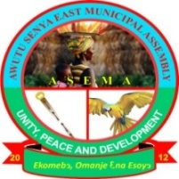
 ENVIRONMENTAL HEALTH AND SANITATION UNIT

2025 ANNUAL REPORT

JANUARY, 2025
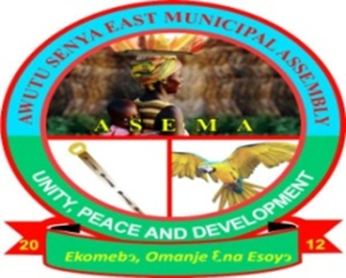

`

AWUTU SENYA EAST MUNICIPAL ASSEMBLY
ENVIRONMENTAL HEALTH AND SANITATION UNIT

TABLE OF CONTENTS PAGE
PREFACE 4
1. Introduction 5
2. Administration 8
3. Universal Salt Iodization (USI) Monitoring 10
4. Food Hygiene and Safety 12
•2025 Annual Food/Drink vendors Health screening and certification
• Meat Inspection
5. Routine Premises Inspection 22
6. Law Enforcement 26
7. Environmental Health Staff and Sanitation Service Providers Quarterly 27
Performance Review Meetings
• Supervision of Private Sanitation Service Providers
8. Public Cleansing 30
9. Solid Waste Management 34
• Clearing of existing heaps of refuse (Collection, Haulage or Transportation and Disposal of Solid Waste)
- Management of Final Disposal Site (FDS)
• Household, Industrial and Commercial Waste Collection
• Acquisition of Sanitary Tools
- Monthly National Sanitation Day Clean Up Exercises

10. Liquid Waste Management 37
• Catch pit Construction and Sullage Disposal
- Public Toilet Management
- Public Drain Cleansing
11. Disease Pest and Vector Control 38
12. Market Sanitation 38
13. Environmental Monitoring and Standards Enforcement and 39
Household latrine Promotion
14. Healthcare Facility Sanitation 40
15. School Health Programmes 40
16. Control and Prevention of Cholera Outbreak
17. Health Promotion and Education
44
18. Promotion of Latrine Construction (Household and Public)
19. Environmental Monitoring and Standards Enforcement and Household
Latrine promotion 47
20. Environmental Enhancement Programs 48
21. Tourism Related Activities
22. Research Activities 53
23. Inter-Agency Collaboration 54
24. Revenue Mobilization 55
25. Constraints and Challenges 56
26. Achievements 56
27. Conclusion 57
28. Recommendations 57
29 Planned Activities for 2026 58

PREFACE
The Environmental Health and Sanitation Unit of Awutu Senya East Municipal Assembly 2025 Annual Report is a comprehensive document that provides a detailed and an in-depth summary of actual and factual activities undertaken by the Unit during the year under review. The report also contains photographs of activities undertaken and graphs where necessary to enable one to better appreciate its contents. It is worth mentioning that the activities carried out are basically those enshrined in the Assembly’s MSESSAP and National Sanitation Policy documents which are the Master working documents of the Unit and the Municipal Assembly for that matter.

1. INTRODUCTION
  - Profile Of The Municipality
The Awutu Senya East Municipality (ASEM) is one of the newly created Municipalities in the Central Region. It was carved out of the former Awutu Senya District in 2012 and established as Municipality by Legislative Instrument (LI) 2025 with Kasoa as its capital. The rationale was to facilitate the government’s decentralization programme and local governance system. Statistics from the 2021 PHC peg the total population of the Municipality at around 236,527 with an annual growth rate of 3.0 percent (GSS). This is about 4.9 percent of the Central Region population. The male population is 48.1 percent while the female population is 5.9 percent. ASEM is highly urbanised due to its proximity to Accra, the capital city of Ghana. Only 15 percent of the population lives in rural areas in the Municipality (GSS, 2021). Due to its strategic location, rural-urban and urban-urban migration is a common phenomenon in the Municipality. The major settlements of the Municipality with high population densities are Kasoa, Opeikuma, Adam Nana, Kpormetey, Ofaakor, Akweley, Walantu and Zongo. The high migration and the urbanization rates coupled with poverty, inadequate and insufficient housing and land speculation has led to development of Kasoa Zongo and Adakope Slums in the Municipality. The slum areas are characterized by increased vulnerability to environmental health problems, intermittent fire outbreaks in part due to illegal electricity connections and increase vulnerability among women, children and youth (GSS, 2021).
The results of a recent Geographic Information System (GIS) survey undertaken in 2018 by officials of ASEMA were used to map urbanization in ASEMA. Due to local factors vis-à-vis other economic factors, migrants from near and far are attracted to the Municipality. The survey revealed that the top three migrant origins are Accra, Assin Foso and Gomoa Fetteh. On arrival in the Municipality, the majority of the in-migrants looked for low-cost and third-class communities like Walantu, Zongo, Opeikuma, and CP to settle. Some of them can only find and dwell in structures such as uncompleted buildings, kiosks and containers. The existence of such dwellings without any form of control from the local authorities has contributed to the developments of slums in the Municipality.
1.1.2 Land Tenure System
Land in Municipality is owned by chiefs, clans of family heads who hold in trust for their subjects. Land can be acquired through direct purchase, rent, leasehold and share cropping. The fact that these parcels of land are inherited through parents or grandparents from one generation to another has led to uncertain ownership status of the lands and multiple sales, resulting in litigation and chieftaincy disputes. This situation has also contributed to the rapid loss of farm lands to residential developments in the Municipality (GSS, 2021).
1.1.3 Water and Sanitation
Lack of potable water is a major challenge confronting the Municipality. About 45 percent of households, commercial and industrial activities depend on water tanker services while 30 percent have access to pipe water. About 20 percent depend on streams or dams while 5 percent use the borehole system (GSS, 2021).
Figure1. Water Coverage in ASEM

Source ASEMA, 2014

Sanitation services and sanitary practices within the Municipality are poor. Significant quantities of solid and liquid waste are generated in the Municipality due to extensive trading activities coupled with the large central market at Kasoa. About 1,414 tonnes of solid waste are generated monthly in the Municipality (Zoomlion Ghana Limited, 2013). Only 31percent of household have their waste collected and sent to formal disposal site. About 44.7percent of household burn their waste, 8.6percent dump their waste in public containers, while 8.4 percent dump their waste in open spaces indiscriminately (GSS, 2021). About 53percent of household throw liquid wastes in their compounds, 25.6percent of household throw liquid waste on the streets/outside while 11.3 percent throw the liquid waste in gutters. Only 3percent and 2.4percent of households dispose of liquid waste through the sewage system and drainage into gutters respectively in the Municipality (GSS, 2021)
Figure 2: Solid and Liquid Disposal in ASEMA

2. ADMINISTRATION
2.0 Mission Statement
The principal role of the Environmental Health and Sanitation Unit of the Awutu Senya East Municipal Assembly is to provide and protect public health by ensuring the provision of basic requirements and services for a healthy environment in collaboration with other stakeholders.
2.1 Manpower Information
2.1.1 Technical Staff in Order of Seniority
S№ | Grade | Number At Post
1. | Snr.Environmental Health Analyst | 1
2 | Environmental Health Analyst | 2
3. | Chief Environmental Health Officer | 1
4 | Principal Environmental Health Officer | 2
5. | Senior Environmental Health Officer | 3
6 | Environmental Health Officer GD.1 | 1
7. | Environmental Health Officer GD.2 | 1
8 | Chief Environmental Health Assistant | 3
9 | Assistance Chief Environmental Health Assistance | 2
9 | Principal Environmental Health Assistant | 2
10 | Environmental Health Assistant | 3
Total |  | 21

2.1.2 Staff Distribution
S№ | Name of Officer/Assistant | Rank | Station
1. | Godson M. Lodo | SEHAN | Municipal Office
2 | Alberta Quayson | EHA | Ofaakor Zonal Council
3. | John Gavi | CEHO | Adam Nana Zonal Council
5. | Grace Agyekumwaa | SEHO | CP/Walantu Zonal Council
6. | Stephen Kutumpah | SEHO | CP/Walantu Zonal Council
7. | Vicential Aku Dandzo | CEHA | Opeikuma Zonal Council
8. | John Mensah | ACEHA | Ofaakor Zonal Council
9. | Mariam Eyi Bedzo | ACEHA | Akweley/Kaemebre Zonal Council
10. | Mabel Owusu Poku | PEHA | CP/Walantu Zonal Council
11. | Ben k. Dzekle | PEHA | Iron City Zonal Council
12. | Jemima Akoto | PEHA | Iron City Zonal Council
13. | Emmanuel K. Tieku | PEHA | Kaemebre Zonal Council
14. | Magdaline Bonnah | SEHA | Adam Nana Zonal Council
15 | Beauty Dogbey | EHA | Municipal Office
16 | Evelyn Adzo Adzawui | EHA | Adam Nana Zonal Council
17 | Bernice Gawugah | EHO II | Municipal Office
18. | Paa Kwasi Asiedu | EHO I | Municipal Office
19. | Esinam Dzramado | EHA | Opeikumah
20 | Bright Anim | EHAN | CP/Wallantu Zonal Council
21 | Frances Ali | ACEHA | Iron City Zonal Council

2.1.3 Staff Distribution Analysis
S№ | Name Of Station (Zonal Council) | № of Comm. | Population | Human Resource Management Analysis
 |  |  |  | № of Officer | Comm. Staff Ratio | Pop. Staff ratio | Remarks & Recommendations
1. | Municipal office | DNA | DNA | 4 | DNA | DNA | -
2. | CP/WALANTU | DNA | DNA | 2 | DNA | DNA
3. | Adam Nana Kpormetey | DNA | DNA | 3 | DNA | DNA
4. | Akweley Kaemebre | DNA | DNA | 3 | DNA | DNA
5. | Opeikuma | DNA | DNA | 2 | DNA | DNA
6. | Iron City | DNA | DNA | 3 | DNA | DNA
7. | Ofaakor | DNA | DNA | 2 | DNA | DNA
Grand Total |  | DNA | DNA | 21 | DNA | DNA

2.1.4 Postings

One (1) Officer was posted to the Unit during the year under review.
2.1.5 Retirements/Deaths
No officer went on retirement. No staff passed on during the year under review
2.1.6 Study Leave
No staff was on course (Sandwich/Regular)
2.1.7 Human Resource Development
1. As part of the Assembly’s conscious efforts to address the Human Resource Development gaps there were two staff training programs in the areas of Food Safety and Hygiene in Weija - Accra and Waste Management and Prosecution in Winneba .In all 16 staff benefited. from both trainings..



Picture of participants at the Food Safety and Hygiene training at Weija ,Accra
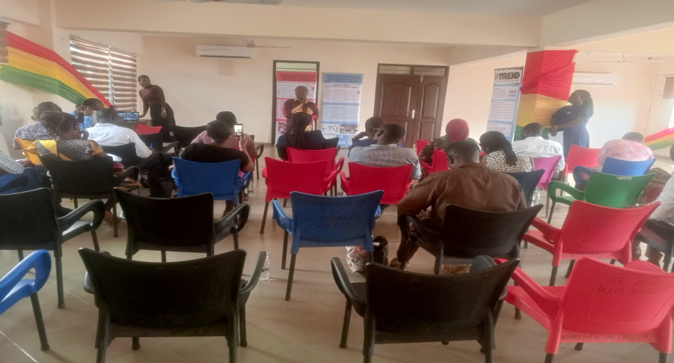

The Above Picture Shows Environmental Health Staff at Food Safety and Hygiene Training Session at Weija,Accra During the Period Under Review
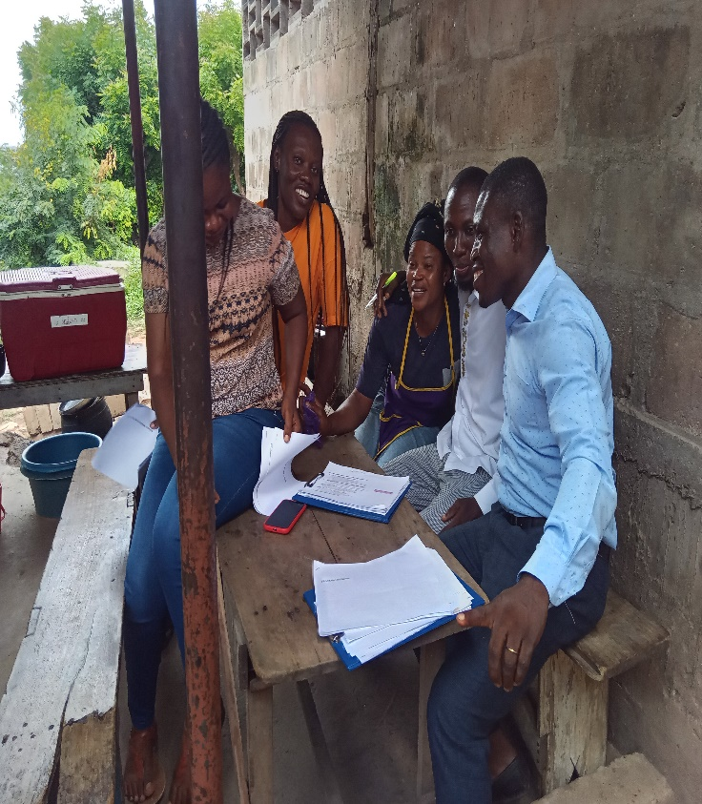
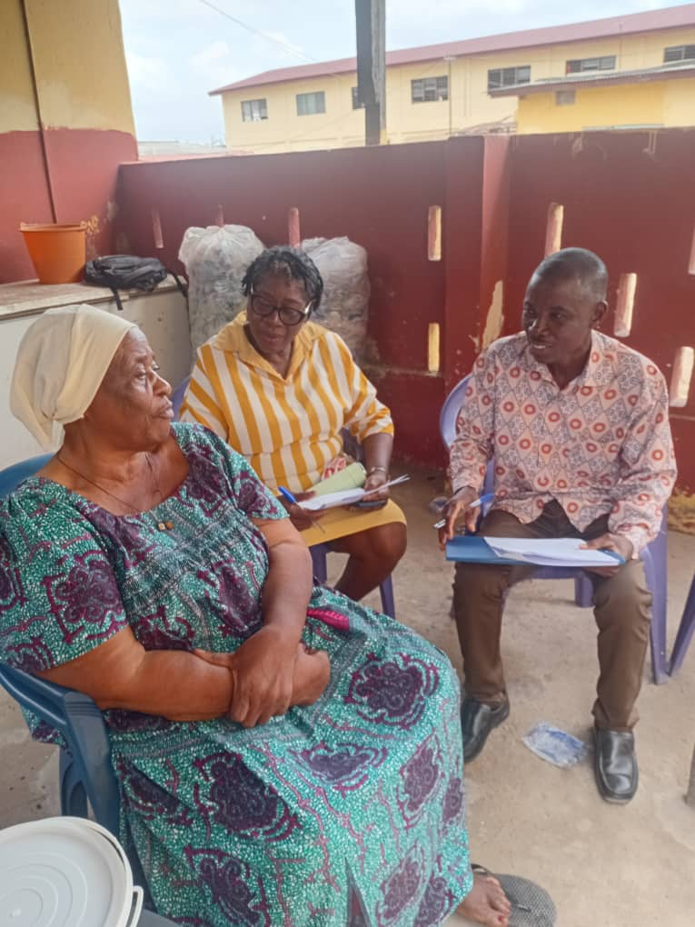
Above Pictures show some Environmental Health Staff in conjunction with TREND conducting Food Safety and Hygiene Survey at Iron City

2. Following the outbreak of Cholera at the later part of the year, there was a capacity development of fifteen of the staff by the Ministry of Sanitation and Water Resources to intensify Cholera Risk Communication and related activities in the Municipality. Staff present was taken through
1. Effective Disinfection in Outbreak Situations
2. Standards and Safety Protocols to Effective Disinfection
3. Management of Safe and Dignified Burial of Cholera Dead Body
4. Overview of Standard Operating Procedures (SOP) for the Prevention and Control of Cholera in Ghana.

5. Personal Protective Equipment (PPEs) for Cholera Response Activities.
6. Risk Communication and Community Engagement.

2.1.8 Promotion/Upgrading
Four Officers were promoted to the grades of Snr. Environmental Health Analyst, Environmental Health Analyst, Environmental Health Officer Grade 1 and Asst. Environmental Health Assistant respectively effective 2023.

2.1.8 Sanitation Labour Force
S№ | Zonal Office | Male | Female | Total
1. | Adam Nana/Joemends Kpormetey | 5 | 11 | 16

2.1.9 Logistics
The Unit had the following logistics for environmental health and sanitation delivery.
S№ | Logistics | Number | Condition
1. | Computer | 1 | Spoilt
2. | Knapsack Spraying Machine | 3 | Fair
3. | Motor bike | 1 | Spoilt
4. | Skip Refuse Truck | 1 | Bad (Auctioned)
5. | Cesspool Emptier | 1 | Bad(Auctioned)
6. | Printer | 1 | Spoilt
7. | Lamination Machine | 1 | Spoilt

3. Universal Salt Iodation (USI)
3.1As part of the Unit’s commitments to achieving and sustaining human and animal consumption of iodized salt through the Universal Salt iodation (USI) programme in the Municipality, the Unit organized a one-day training and educational workshop for salt traders at both Kasoa New and Old Markets.
Topics considered were;
- Public Health Importance of Iodized Salt consumption
- Safe handling of Iodized Salt
- Testing of salt for iodine
- Legal implication of offering non-iodized and inadequately iodized salt for sale to the public. In all 168 salt traders from the two markets benefitted from the training.

3.2 Salt Iodation Monitoring
The Unit in collaboration with Nutrition Unit of Ghana Health Service and sponsorship from UNICEF conducted a number of salt testing for iodine on quarterly basis in the two main markets in the Municipality namely Kasoa New Market and Old Market.
Below is a table of results of the exercise
Table 1
S№ | Date | Sentinel Market | № of Samples Tested | № Positive | %age Positive | Remarks
1. | 71/25 | Kasoa New Market | 60 | 55 | 92 | Failed
2. | 14/2/25 | Kasoa Old Market | 60 | 59 | 98 | Failed
3. | 18/3/25 | Kasoa New Market | 60 | 50 | 83 | Failed
4. | 25/4/25 | Kasoa Old Market | 70 | 65 | 93 | Failed
5. | 23/5/25 | Kasoa New Market | 70 | 69 | 99 | Failed
6. | 17/6/25 | Kasoa Old Market | 70 | 65 | 93 | Failed
7. | 22/7/25 | Kasoa New Market | 80 | 77 | 96 | Failed
8. | 12/8/25 | Kasoa Old Market | 80 | 78 | 98 | Failed
9 | 19/9/25 | Kasoa New Market | 80 | 71 | 89 | Failed
10 | 14/10/25 | Kasoa Old Market | 90 | 83 | 92 | Failed
11 | 21/11/25 | Kasoa New Market | 90 | 85 | 94 | Failed
12 | 19/12/25 | Kasoa Old Market | 90 | 84 | 93 | Failed

As a means of ensuring that the Markets pass next time i.e. score 100%, traders whose salt tested iodine negative were educated on safe handling of iodized salt and warned.

4. FOOD HYGIENE, SAFETY AND NUTRITION
4.1 In view of the alarming rate at which communicable diseases such as typhoid fever, dysentery, cholera etc. are spreading among the populace through unhygienic preparation and sale of food and drinks, the Unit during the period of reporting organized and ensured health screening of food and drink vendors in the Municipality.
Below are the details of the outcome
- Number of food/drink vendors registered – 10,109
- Number of food/drink vendors health screened, and certified fit -9,107
Out of the total number of the 10,109 vendors that were registered and health screened across the Municipality, 9,107 representing 90% of them were declared and certified fit to sell food/drink for public consumption during the year review.

Fig. 2 Bar Chart showing the number of vendors registered, screened and certified fit and number not screened in the Municipality.
- Number of food vendors found to be healthy carriers of typhoid fever – 1,002(10%) of the total number of food/drink vendors screened.

Fig. 3 Pie Chart showing the number of vendors screened and found to be carriers of Typhoid fever and those without Typhoid fever.
As a way of breaking the mode of transmission of Typhoid fever to safeguard public health, all food and drink vendors food to be healthy carriers of the disease were treated and confirmed cured by a medical officer before allowed to prepare and sell food/drink to the public. They were also given hygiene education.

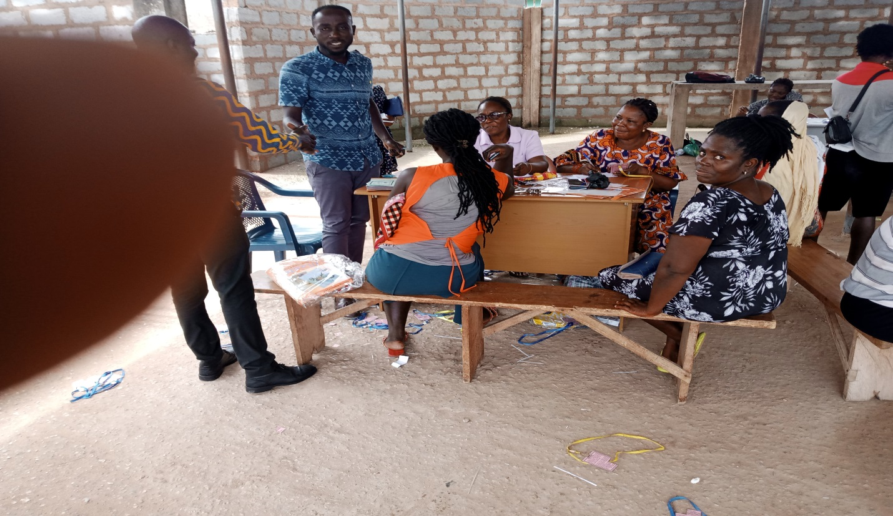
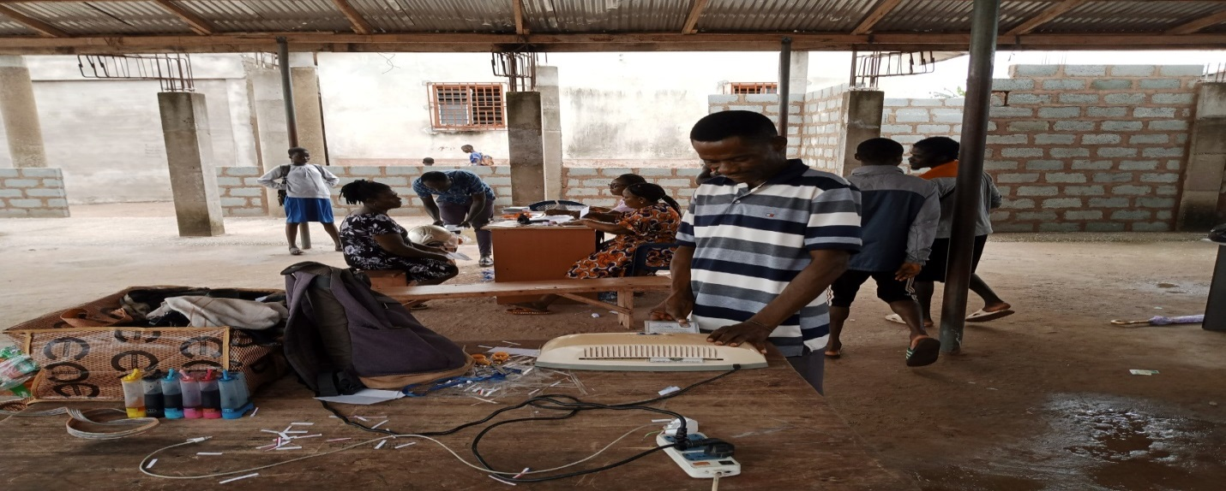
Above Pictures Show Environmental Health Staff of Akweley/Kaemebre Zonal Council Conducting 2025 Food/Drink Vendors Health Screening And Certification Exercise.

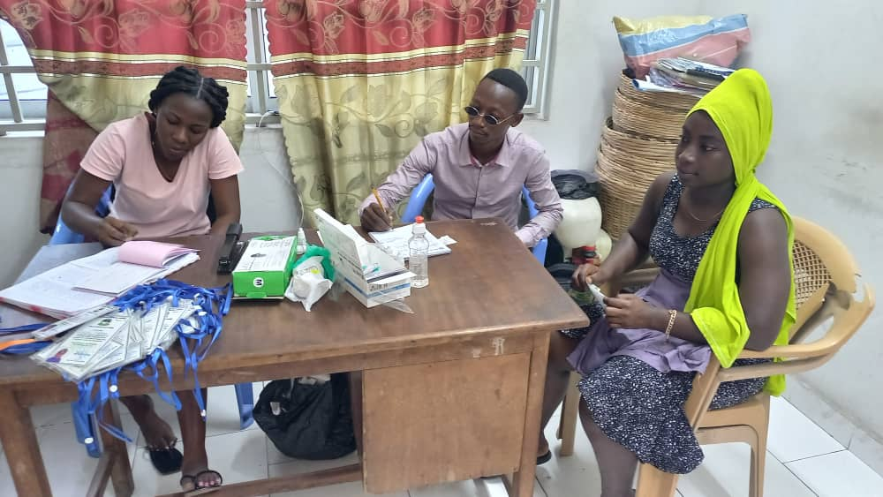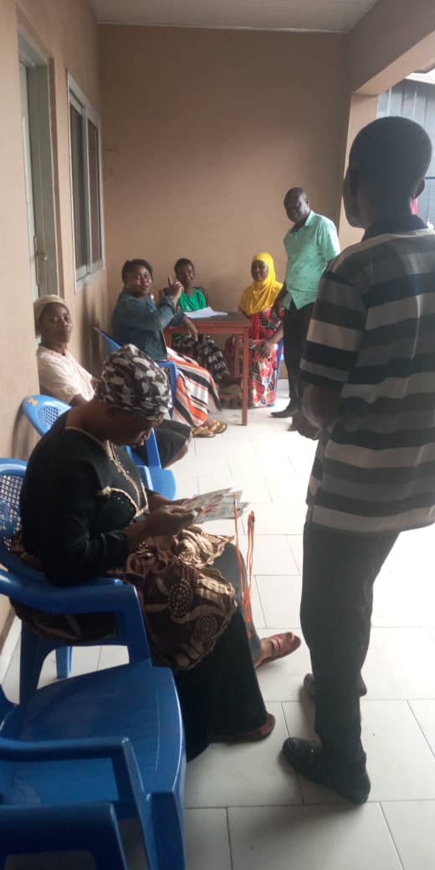
Above Pictures Show Environmental Health Staff of Iron City Zonal Council Conducting 2025Food/Drink Vendors Registration and Health Screening Exercise

4.2 Food Hygiene and Safety Enforcement
The Unit during the period under review intensified inspection of food/drink and vending sites in the Municipality to educate vendors operating in unsanitary environment and prosecute recalcitrant vendors who exposed food items to flies and dust hence making them unwholesome for human consumption and to call to order vendors who either operate with fake health certs or failed to undergo health screening and certification.
The table below shows progress made so far in the area of health screening and certification of food of food vendors since 2016.
Year | 2017 | 2018 | 2019 | 2020 | 2021 | 2022 | 2023 | 2024 | 2025
No of vendors health screened and certified | 1981 | 2461 | 3564 | 3,864 | 5541 | 2750 | 3341 | 1651 | 10109

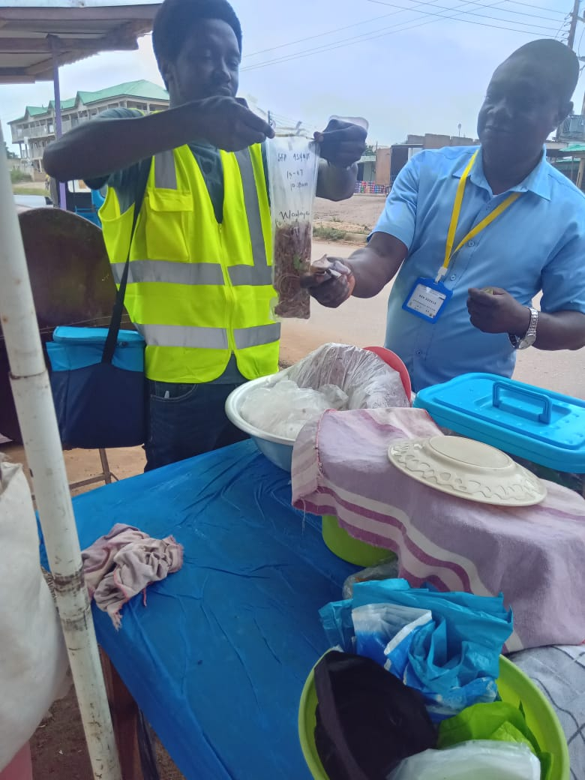
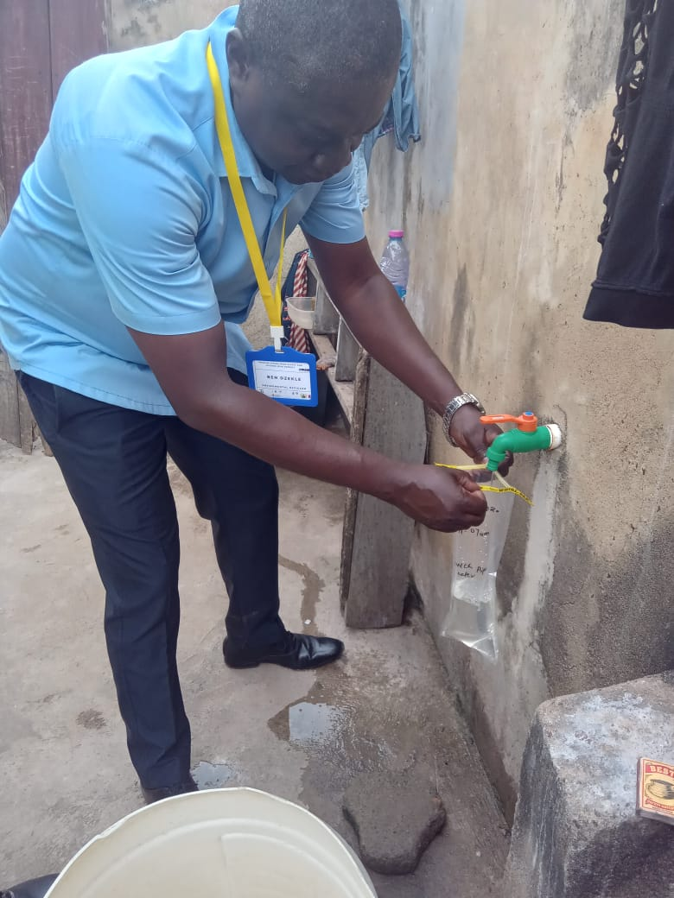
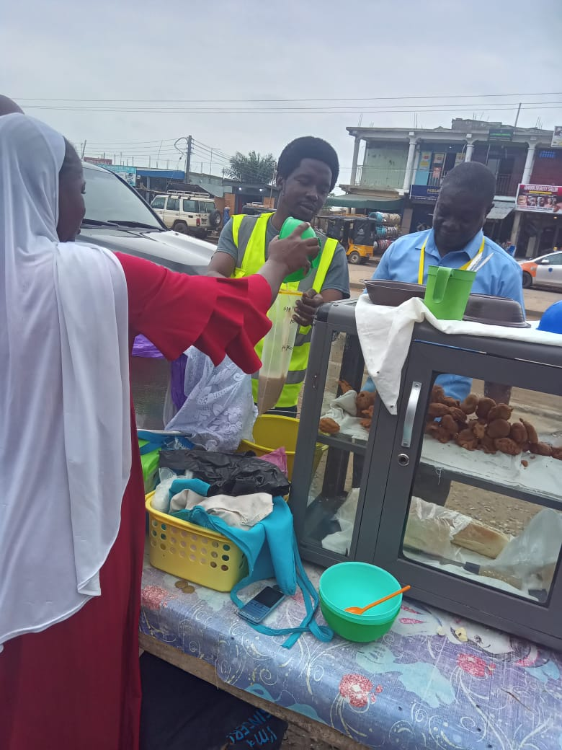
Above Pictures Show Staff Of Environmental Health Staff and TREND Educating food vendors on Food Safety and Hygiene and collecting food and water samples for Lab analysis to ascertain possible Food Contamination.

4.3 Meat Inspection
To ensure that the populace bought and consumed wholesome meat, the Unit during the period under review intensified meat inspection and slaughter house duties. Activities undertaken in this respect were
- Anti-Mortem and post mortem inspection of food animals.
- Hygiene and sanitation standards enforcement at the slaughter house.
- Effective and efficient waste management and
- Enforcement of the Assembly’s slaughter house bye-laws
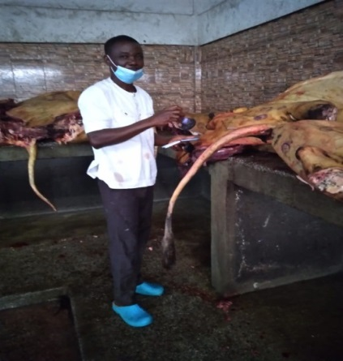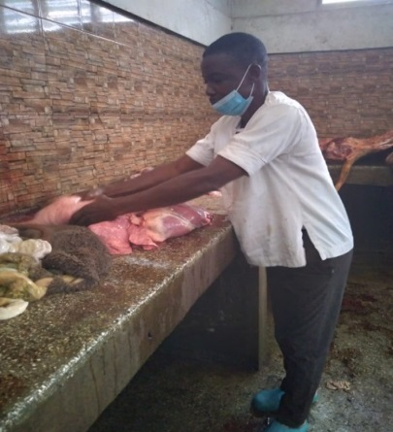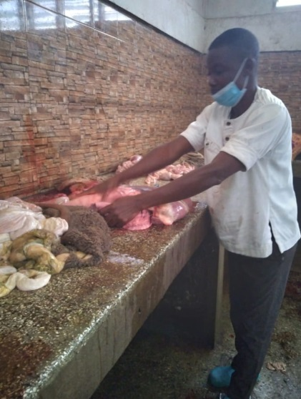
An Environmental Health Officer Inspecting Meat at the Kasoa New Market Slaughter House on 30th June 2025.

4.4 Type and Number of Animals Slaughtered In the Municipality

S№ | Type of animals slaughtered and inspected | № slaughtered and inspected
1. | Cattle | 1,380
2. | Goat | 751
3. | Sheep | 646
 | TOTAL | 2,777

4.5 Data on Common Disease Conditions Detected
S№ | Animal | Disease Condition | № Detected
1. | Bovine | - Lymphodemitis  - Pleurisy  - Abscesses (LOCALIZED)  - Hepatitis  - Cirrhosis | 27  39  37  45
2. | a) Sheep  b) Goat | 1. Peritonitis  2. Pneumonia  3. Cystercercus ovis  4. Cirrhosis  5. Hepatitis  6. Tapeworm | 33  35  34  42  35  33

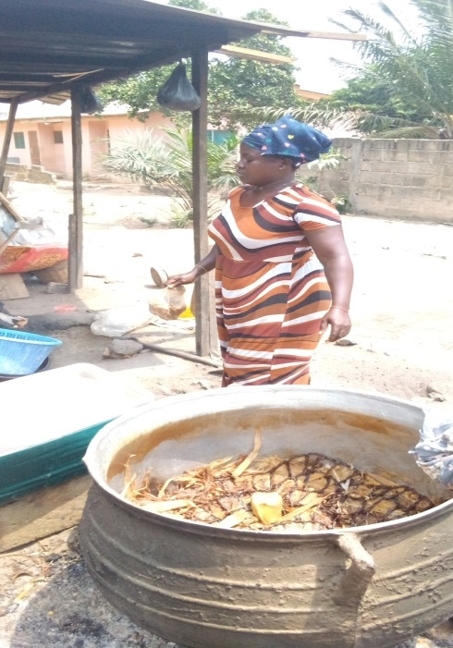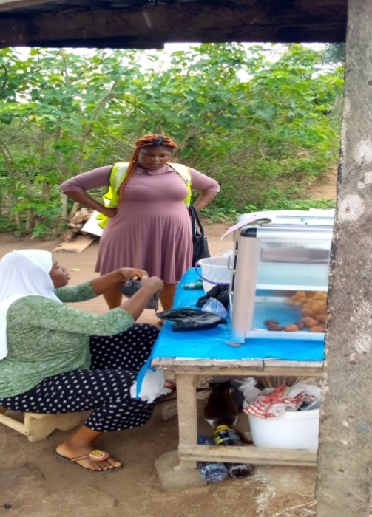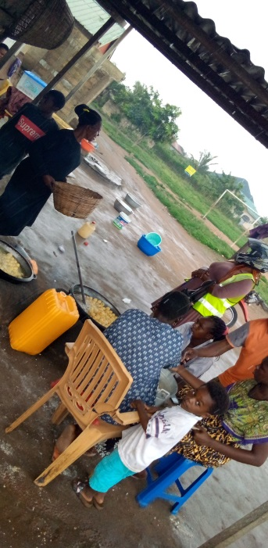
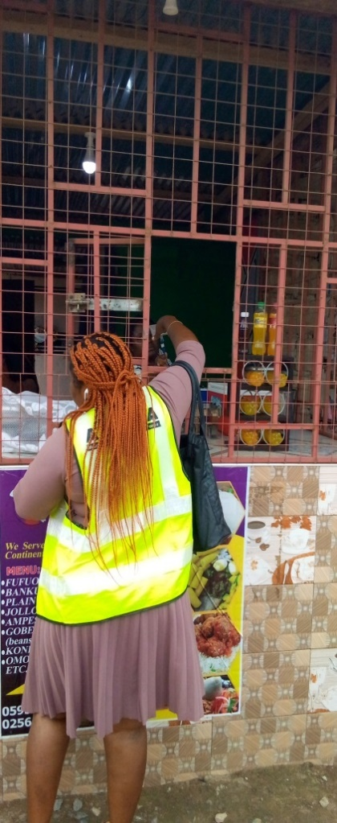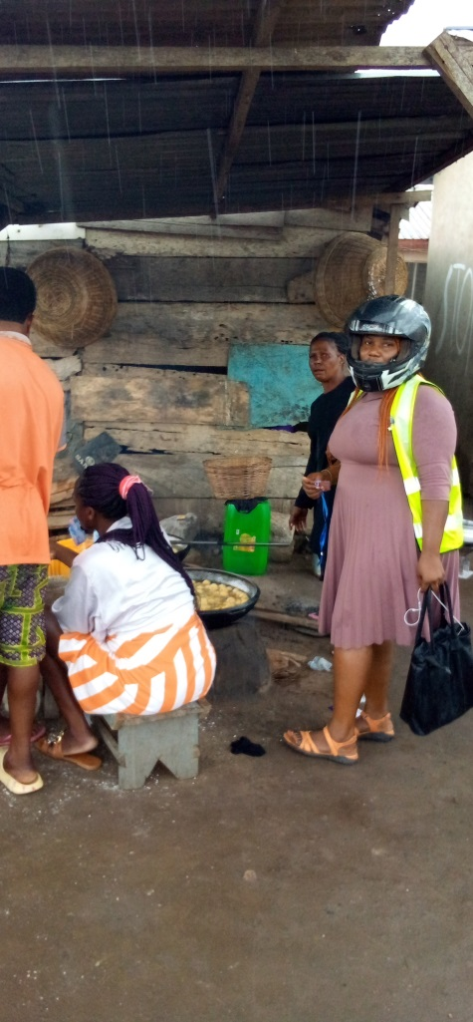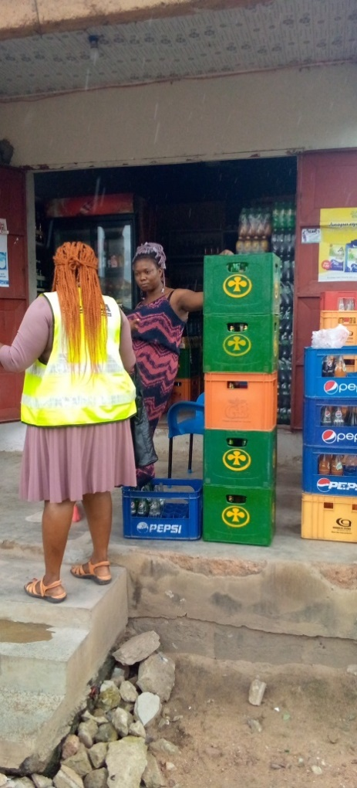
Pictures of Environmental Health Staff from Adam Nana Kpormetey Zonal Council orienting a group of food vendors on nutrition, food hygiene and safety practices on26th August, 2025
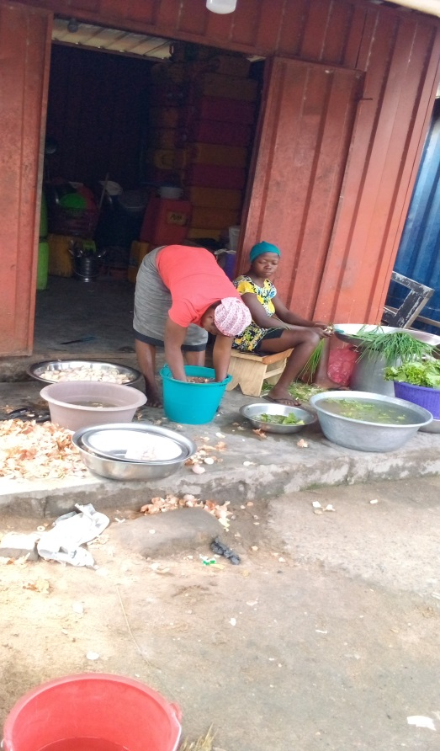
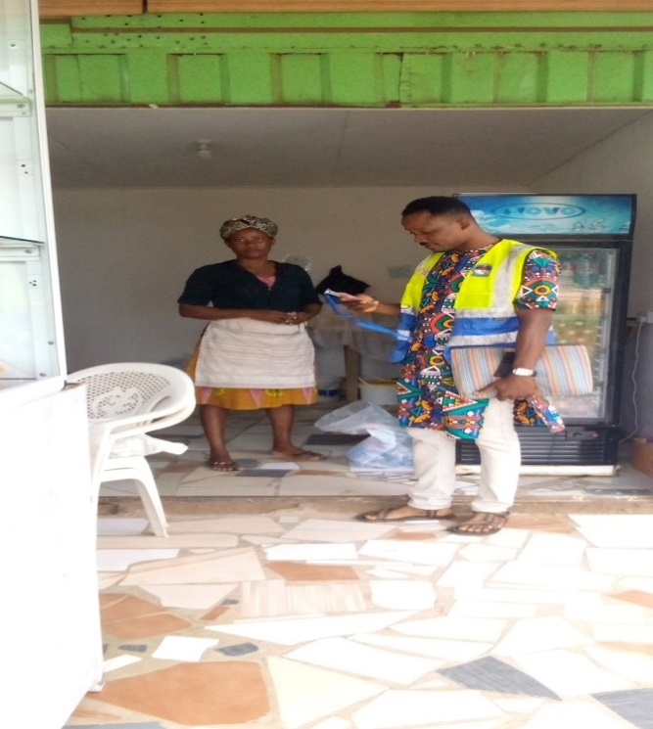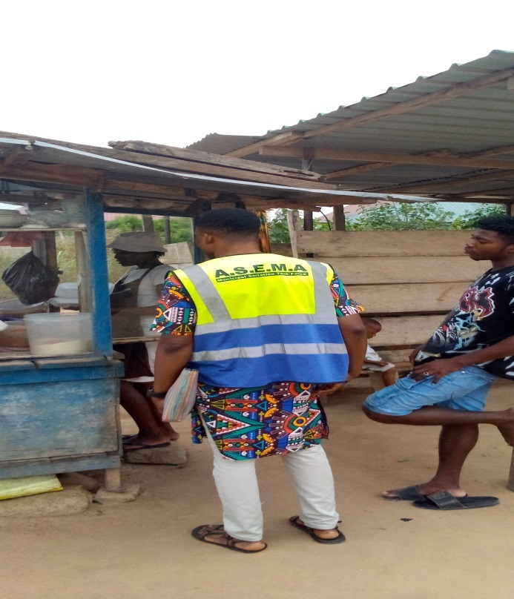
Pictures of Environmental Health Staff from Akweley Kaemebre Zonal Council orienting a group of food vendors on nutrition, food hygiene and safety practices on 21st October 2025

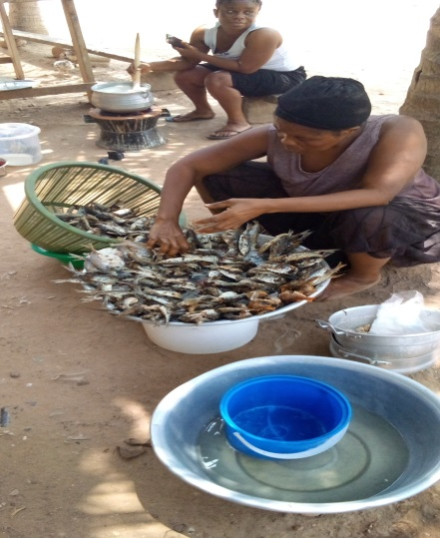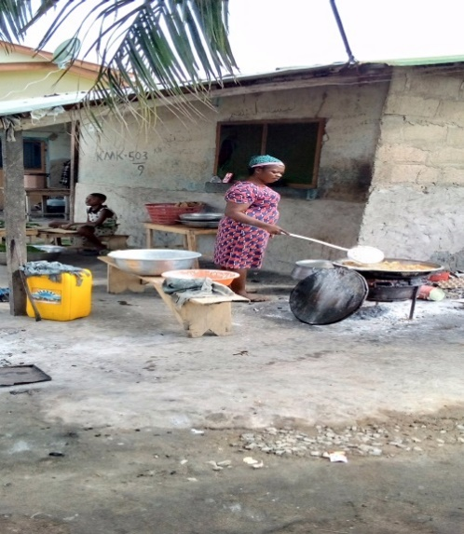
Pictures of Environmental Health Staff from Iron City Zonal Council orienting a group of food vendors on nutrition, food hygiene and safety practices on 11th November, 2025
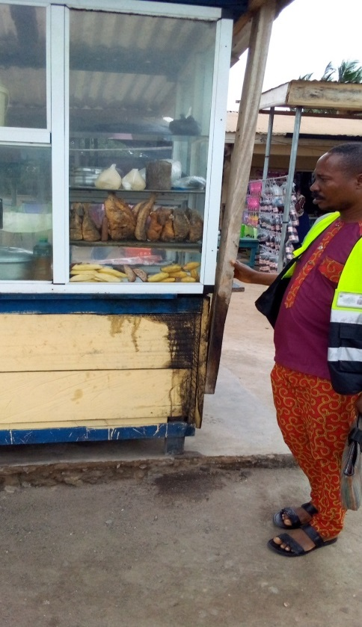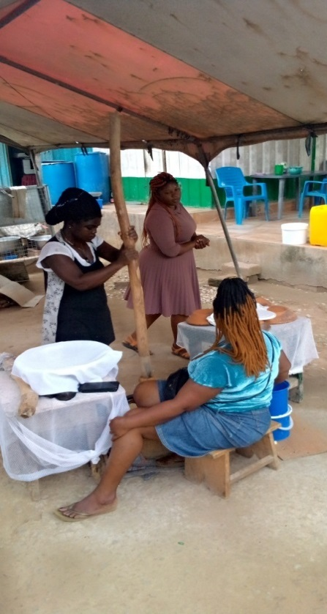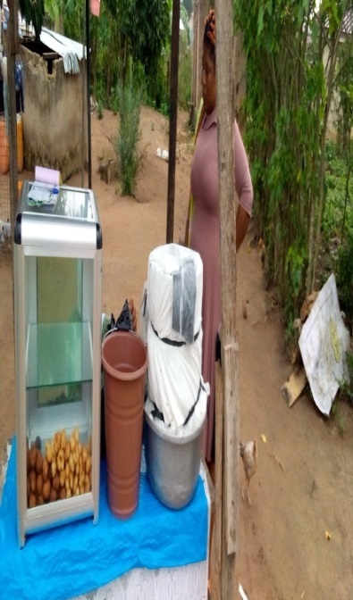
Pictures of Environmental Health Staff from Opeikuma Zonal Council Orienting a Group of Food Vendors on Nutrition, Food Hygiene and Safety Practices on 21st August, 2025 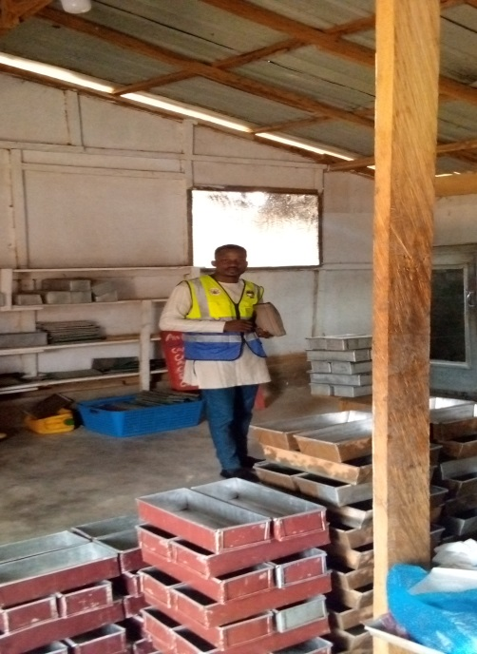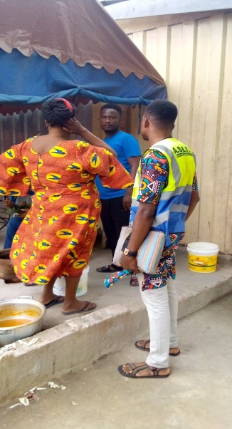
Pictures of Environmental Health Staff from Ofaakor Zonal Council Orienting A Group Of Food Vendors On Nutrition, Food Hygiene And Safety Practices On 17th July, 2025.

5. ROUTINE PREMISES INSPECTION
To ensure that all types of premises conformed to hygiene and sanitation standards in the Municipality, the Unit during the year under review intensified routine premises inspection. Below is a table of data on the categories of premises available in the Municipality.
5.1 Data on Categories of Premises in the Municipality
S№ | Category Of Premises | № in the Municipality(Target) | No. Inspected | % Inspected
1. | Residential | 34,340 | 19,225 | 56
2. | Hotels/Guest Houses | 118 | 113 | 96
3. | Restaurants | 175 | 166 | 95
4. | Eating bars | 432 | 401 | 93
5. | Drinking bar | 5670 | 4781 | 84
6. | Local industries | 125 | 115 | 92
8. | Water Producing Factories | 44 | 44 | 100
9. | Garages | 77 | 71 | 92
10. | Lorry terminals | 11 | 11 | 100
11. | Private basic schools | 329 | 303 | 92
12. | Private SHS | 3 | 3 | 100
13. | Public basic schools | 47 | 47 | 100
14. | Public SHS | 1 | 1 | 100
15. | Bakeries | 191 | 173 | 91
16. | Privately Owned Public Toilets | 58 | 58 | 100
17. | Cold Stores | 125 | 111 | 89
18. | Private Clinics | 22 | 22 | 100
19. | Public Health facilities | 8 | 8 | 100
Total |  | 41,776 | 25,653 | 61℅

5.2 Data on Categories of Premises Inspected
S№ | Type Of Premises | № Of Premises | № & Percentage Inspected | Number Good(without Nuisances) | Number And Percentage With Nuisances | Type Of Nuisances Detected And Abated
1. | Residential | 34,340 | 19225 (56%) | 8551 (44%) | 10674 (56%) | 1. Growth of weeds  2. Human excreta on premises  3.Insanitary drains and bath houses, toilets  4. Indiscriminate dumping of wastes
2. | Hotels/Guest Houses | 118 | 113 (96%) | 61 (54%) | 52 (46%) | 1. Insanitary bath houses, toilet and drains  2. Indiscriminate dumping of waste
3. | Restaurants | 175 | 166 (95%) | 100 (60%) | 66 (40%) | 1. No toilet facilities  2. Operating without health certificate  3.  Indiscriminately dumping of refuse
4. | Eating bars | 432 | 401 (93%) | 158(39%) | 243 (61%) | 1. No toilet facilities  2. No urines  3. Operating without health certificate  4. Uncovered litter bins
5. | Drinking bars | 5670 | 4781 (84%) | 2301 (48%) | 2480(52%) | 1. Operating without health certificate  2. No toilet and urinal  3. Housefly infestations
6. | Local industries | 125 | 115 (92%) | 39 (34%) | 76 (66%) | 1. Operating without health certificate  2. Insanitary drains  3. Housefly infestations
7. | Water Producing Factories | 44 | 44 (100%) | 25 (57%) | 19 (43%) | 1. Operating without health certificate  2. No FDA license  3. Indiscriminate dumping of waste
8. | Garages | 77 | 71 (92%) | 31 (44%) | 40 (56%) | 1. Indiscriminately dumping of refuse  2. Growth of weeds
9. | Lorry Terminals | 11 | 11 (100%) | 9 (82%) | 2 (18%) | 1. Indiscriminately littering
10. | Private Basic Schools | 329 | 303 (92%) | 150 (49.50%) | 153 (50.50%) | 1. Insanitary urinal and toilet  2. Indiscriminately dumping of waste  3. Operating without health certificate  4. Growth of weeds
11. | Public Basic Schools | 47 | 47 (100%) | 13 (28%) | 34 (72%) | 1. Insanitary urinal and toilet  2. Indiscriminate dumping of refuse  3. Operating without health certificate  4. Growth of weeds
12. | Bakeries | 191 | 173 (91%) | 69 (40%) | 104 (60%) | 1. Insanitary toilets, bath and drains  2. Operating without health certificate
13. | Privately Owned Public Toilets | 58 | 58 (100%) | 15 (26%) | 43 (74%) | 1. Accumulation of anal cleansing materials  2. Dirty floors and walls  3. Housefly infestations  4. Dirty surroundings  5.Improper waste management
14. | Private Clinics | 22 | 22 (100%) | 15 (68%) | 7 (32%) | 1. Insanitary urinal, toilet and drains  2. Improper waste management
15. | Public Health facilities | 8 | 8(100%) | 3(38%) | 5(62%) | 1. Waste water draining through nearby settlements  2. Occasional spillage from skip container  3.Improper waste management
 | Total Number Of Premises | 41,647 | 25,538(61%)

5.3 Actions Taken
Actions taken to abate nuisances detected to improve on hygiene and sanitation situations of premises inspected were;
- Hygiene education
- Issuance of both written and verbal abatement notices
- Issuance of prepare for court summonses
- Follow-up visits to ensure compliance with abatement notices and
- Prosecution of sanitary offenders
- Follow up visits to ensure compliance with food hygiene standards at food/ drink preparation and vending sites
- Food Hygiene, Safety and Nutrition education of food vendors.

6. LAW ENFORCEMENT
Below is a table of outcome of court prosecutions during the period under review to serve us deterrent to the populace.
S№ | Month | No of offenders  prosecuted | Successful prosecution
1. | January | -
2. | February | -
3. | March | -
4. | April | -
5. | May | -
6. | June | -
7 | July | -
8 | August | 26 | 22
9 | September | 33 | 29
10 | October | 29 | 28
11 | November | 20 | 17
12 | December | 21 | 18
TOTAL |  | 129 | 114

Court fines ranging from minimum of forty penalty units i.e. Gh₵480.00 to maximum fines of eighty penalty units i.e. GH₵1,200.00 were imposed on offenders who were successfully prosecuted and all amount generated was however paid into the consolidated funds.

6.1 Overall Outcome of Court Prosecution
Find below the overall outcome of court prosecution during the period under review
- Number of criminal summonses served - 129
- 5Number of successful prosecution - 114
- Number of unsuccessful prosecution - 15
- Number of Bench warrants executed - 16
- Number of offenders cautioned, acquainted and discharged - 1

7. ENVIRONMENTAL HEALTH STAFF AND SANITATION SERVICE PROVIDERS QUARTERLY PERFORMANCE REVIEW MEETINGS
In line with the Unit’s 2024 Annual Action Plan (AAP) there was a mid- year performance review meetings led facilitated by the Unit in July, 2024. The objectives of the meeting was to
- Provide a common platform for both staff of the Unit and the service providers to account for their stewardship in the area of Environmental Health and Sanitation Service delivery in the Municipality during the period under review.
- Bring sanitation service providers together to passionately brainstorm on pertinent sanitation challenges confronting the Municipality and arrive at sustainable solutions to address them and
- Strengthen the collaboration between the Assembly and invited stakeholders to enhance sanitation service delivery.
Participants at the meetings were
- Honorable Assembly Members
- Staff of Honest Waste Company
- Staff of RKM Waste Company

- Staff of Environmental Health Unit
- Honorable Presiding Member
- Operators of privately owned public toilets
- Staff of Zoomlion Company Ltd and
- Staff of Coastal Waste Company

7.1 Supervision of Private Sanitation Service Providers
Solid and Liquid Waste Management constituted a major sanitation service provision in the Municipality during the year of reporting. To ensure sanitation service providers rendered quality services to their clients, the Unit intensified supervision, monitoring and performance assessment of private sanitation service providers in the areas of
- Door-to-door solid waste collection
- Management of Communal Central Container system under Sanitation Improvement Package (SIP) by Zoomlion Ghana Company Ltd
- Privately owned public toilet service
- Privately owned Cesspit emptier service and
- Management of communal Central Containers at the Kasoa New Market by Assembly’s Skip refuse truck.

List and Performance Assessment of Sanitation Service Providers In 2022

Quarter One
SN | Name of service provider | Thematic areas, maximum score and scores obtained by company
SN | Name of service provider | Office Establish  ment  (8) | Documentation  (13.5) | Staffing  (1) | Logistical capacity  (3) | Staff Protection  (2.5) | Client feed back  (15) | Franchise fee payment  (17) | Total marks  (60)(%)
1 | Honest Waste | 0 | 11 | 1 | 1 | 1.5 | 6 | 0 | 20.5(34.17%)
2 | Rural Waste | 0 | 11 | 1 | 1 | 1.5 | 5 | 0 | 19.5(32.5%)
3 | Ameg Waste | 8 | 11 | 1 | 1 | 1.5 | 4 | 0 | 26.5(44.17)
3 | Ataliz Waste | 8 | 11 | 1 | 1 | 1.5 | 4 | 0 | 26.5(44.17%)
4 | Coastal Waste | 8 | 12 | 1 | 1 | 1.5 | 14 | 0 | 37.5(62.5%)
5 | Network Collections | 8 | 10 | 1 | 1 | 1.5 | 4 | 0 | 25.5(42.5%)
6 | RKM Waste | 0 | 12 | 1 | 2 | 1.5 | 14 | 3 | 30.5(50.83%)
8 | Yada Waste | 0 | 7 | 1 | 1 | 1.5 | 7 | 0 | 17.5(29.17%)
9 | Tiger Waste | 0 | 7 | 1 | 1 | 1.5 | 4 | 0 | 14.5(24.17)

Quarter Two
SN | Name of service provider | Thematic areas, maximum score and scores obtained by company
SN | Name of service provider | Office establish  Ment  (8) | Documentation  (13.5) | Staffing  (1) | Logistical capacity  (3) | Staff protection  (2.5) | Client feed back  (15) | Franchise fee payment  (17) | Total marks  (60)(%)
1 | Honest Waste | 0 | 10 | 1 | 1 | 1.5 | 6 | 0 | 19.5(32.5%)
2 | Rural Waeste | 0 | 12 | 1 | 1 | 1.5 | 5 | 0 | 20.5(34.16%)
3 | Ameg Waste | 8 | 10 | 1 | 1 | 1.5 | 4 | 0 | 25.5(42.5)
3 | Ataliz Waste | 8 | 10 | 1 | 1 | 1.5 | 4 | 0 | 25.5(42.5%)
4 | Coastal Waste | 8 | 12 | 1 | 1 | 1.5 | 14 | 0 | 37.5(62.5%)
5 | Network Collections | 8 | 10 | 1 | 1 | 1.5 | 4 | 0 | 25.5(42.5%)
6 | RKM Waste | 0 | 12 | 1 | 2 | 1.5 | 14 | 3 | 33.5(50.83%)
8 | Yada Waste | 0 | 7 | 1 | 1 | 1.5 | 7 | 0 | 17.5(29.17%)
9 | Tiger Waste | 0 | 8 | 1 | 1 | 1.5 | 4 | 0 | 14.5(24.17)

Quarter Three
SN | Name of Service Provider | Thematic areas, maximum score and scores obtained by company
SN | Name of Service Provider | Office establishment  (8) | Documentation  (13.5) | Staffing  (1) | Logistical capacity  (3) | Staff protection  (2.5) | Client feed back  (15) | Franchise fee payment  (17) | Total marks  (60)(%)
1 | Honest Waste | 0 | 10 | 1 | 1 | 1.5 | 6 | 0 | 19.5(32.5%)
2 | Rural Waste | 0 | 11.5 | 1 | 1 | 1.5 | 5 | 0 | 20.5(34.16%)
3 | Ameg Waste | 8 | 9 | 1 | 2 | 1.5 | 4 | 0 | 25.5(42.5)
3 | Ataliz Waste | 8 | 10 | 1 | 1 | 1.5 | 4 | 0 | 25.5(42.5%)
4 | Coastal Waste | 8 | 12 | 1 | 1 | 1.5 | 14.5 | 0 | 38(47.66%)
5 | Network Collections | 8 | 10 | 1 | 1 | 1.5 | 4 | 0 | 25.5(42.5%)
6 | RKM Waste | 0 | 12 | 1 | 2 | 2 | 14 | 3 | 34(56.66%)
8 | Yada Waste | 0 | 7 | 1 | 1 | 2 | 7 | 0 | 18(30%)
9 | Tiger Waste | 0 | 8 | 1 | 1 | 1.5 | 4 | 0 | 15.5(25.83)

8. PUBLIC CLEANSING
As part of the Unit’s mandate to ensure a clean, safe, healthy and pleasant physical environment in all human settlements, the Unit during the period under review closely monitored and supervised both Zoomlion Company Ltd and the few Assembly’s sanitary labourers to cleanse all through fares, markets, streets, open spaces, refuse container sites and lorry parks in the Municipality.The exercise ended around 11: 40 a.m.

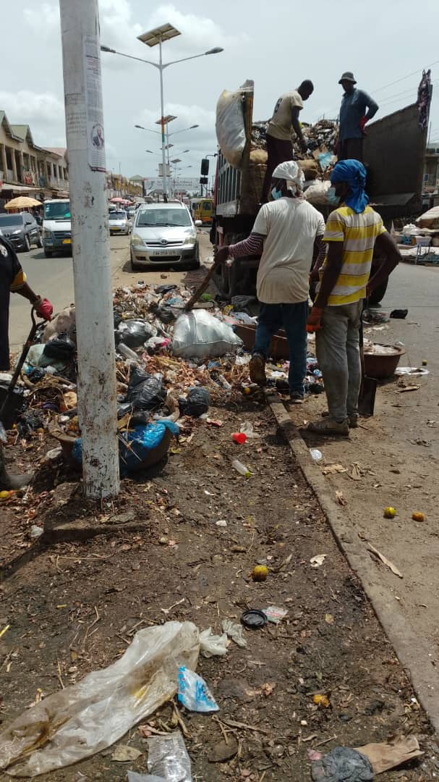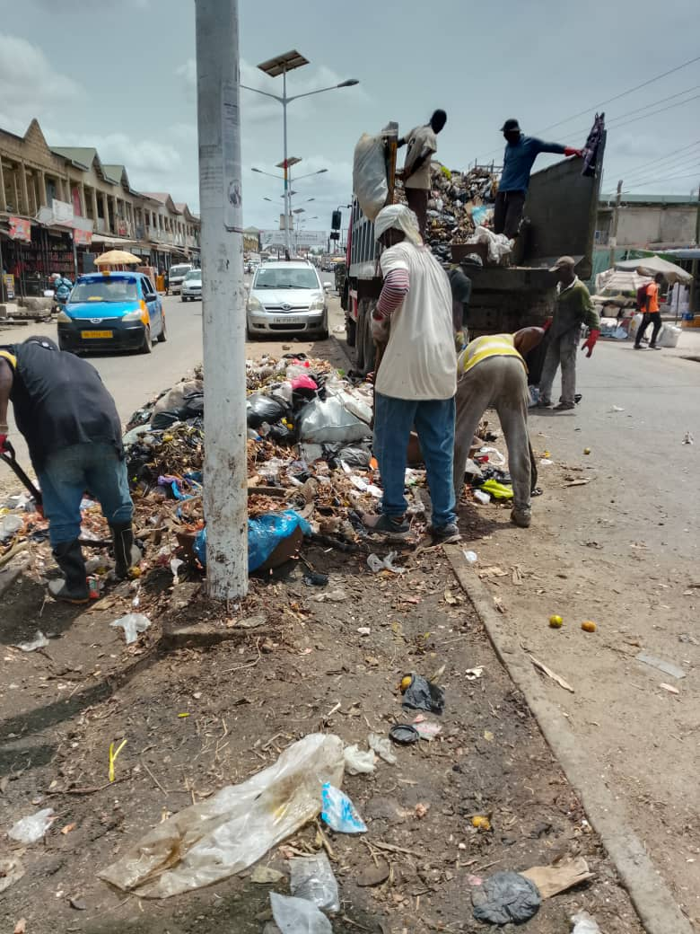
Collection of refuse at the new market and it environ during clean up exercises on the 3rd may 2025

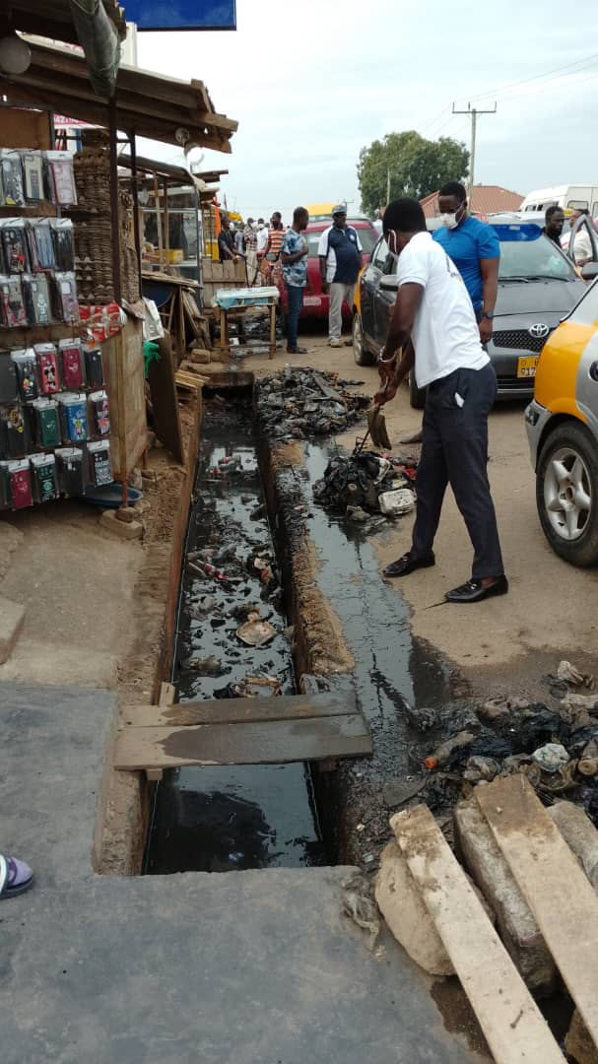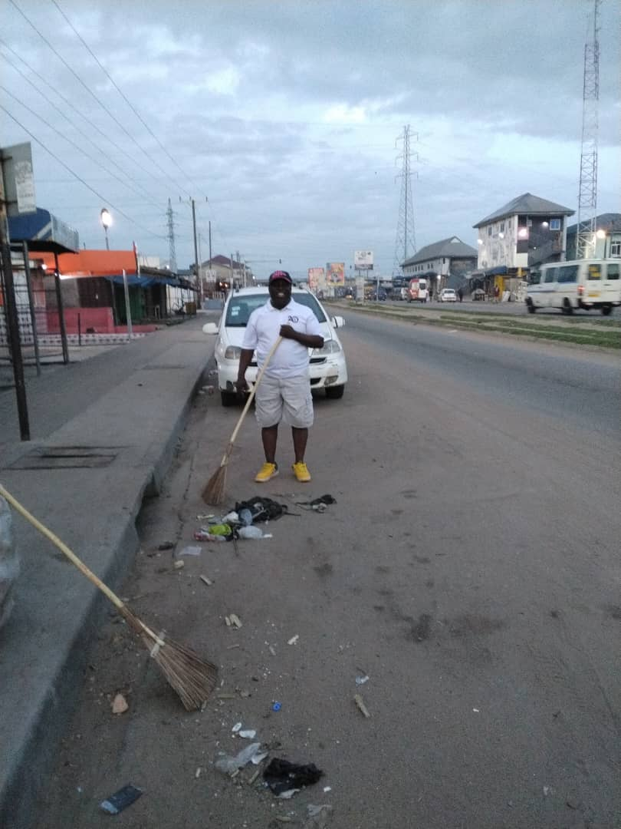 Sweeping and distilling of public drains during clean up exercises along Bawjiase road on 5th July, 2025

The snapshots below show the clean-up activity. H
hh

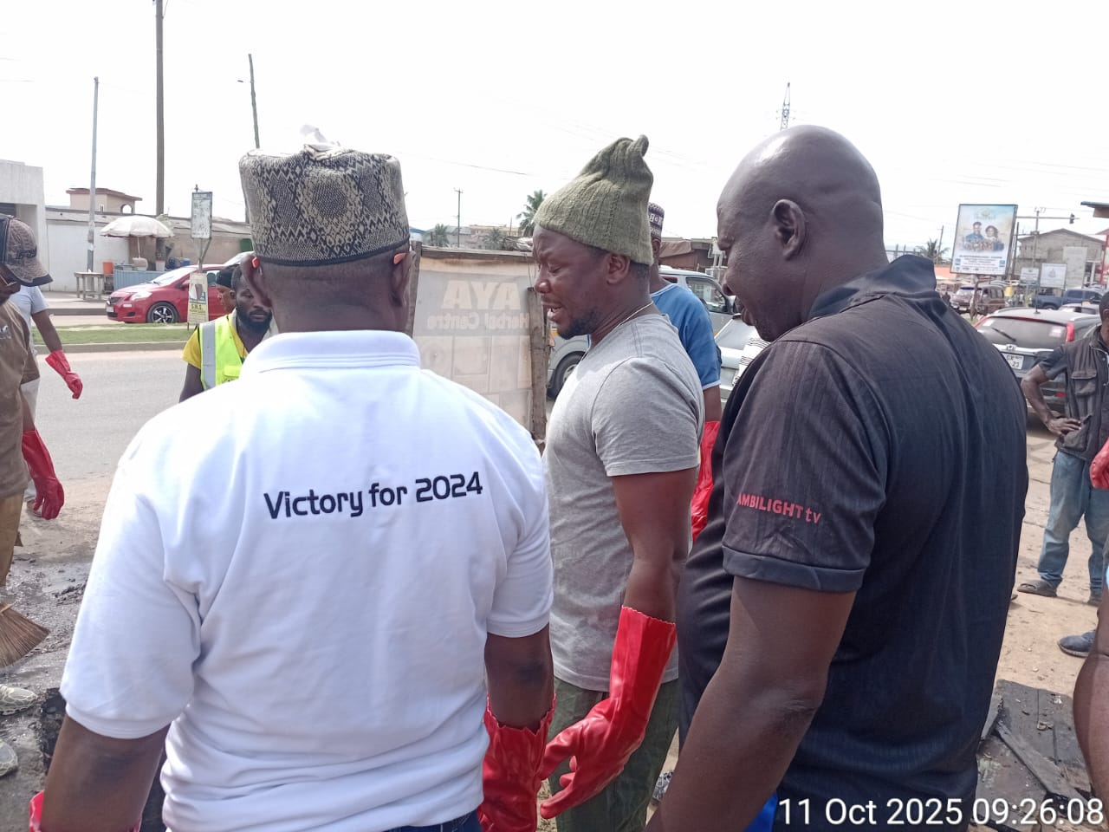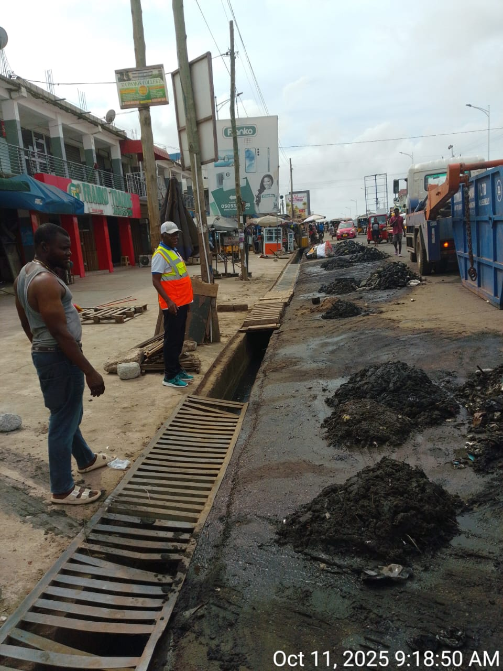
Hon. Municipal Chief Executive, Hon. Assembly members and the Municipal Environmental Health Officer are participating in the National Sanitation Clean Up Exercise at the Kasoa CBD on the 11th October 2025

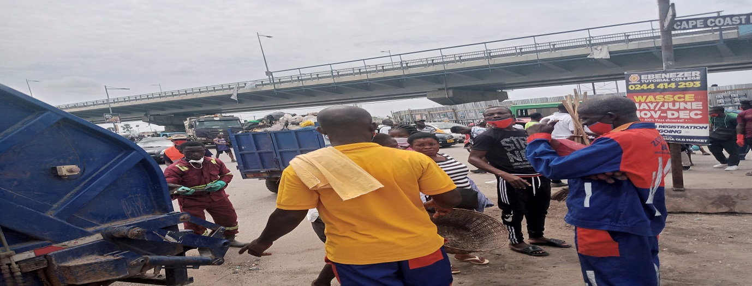
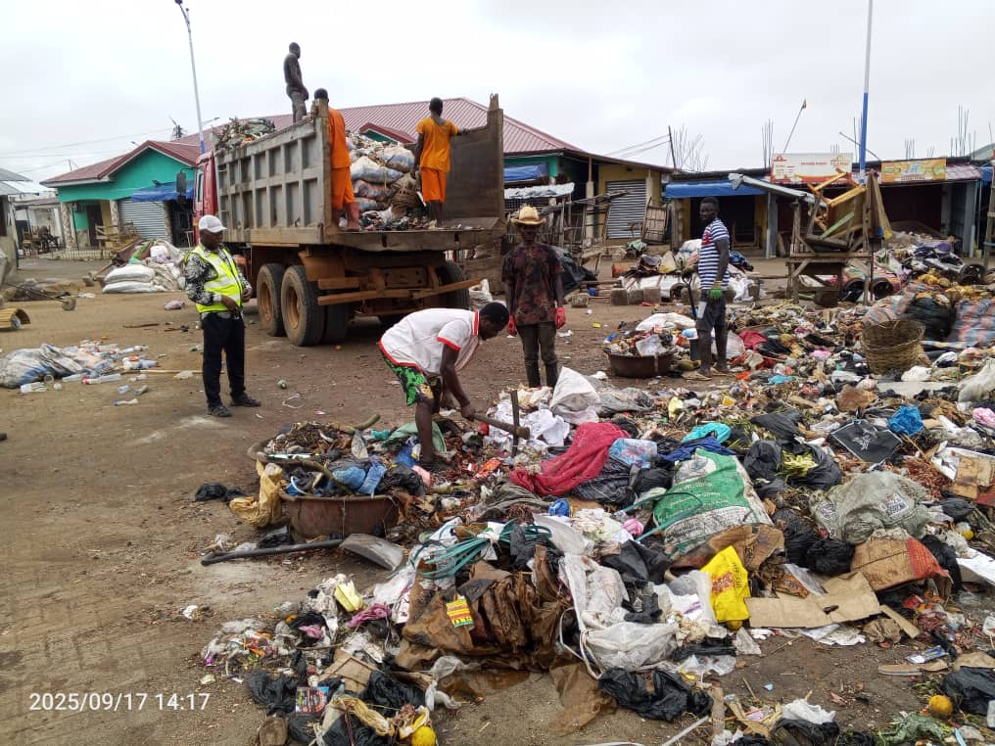

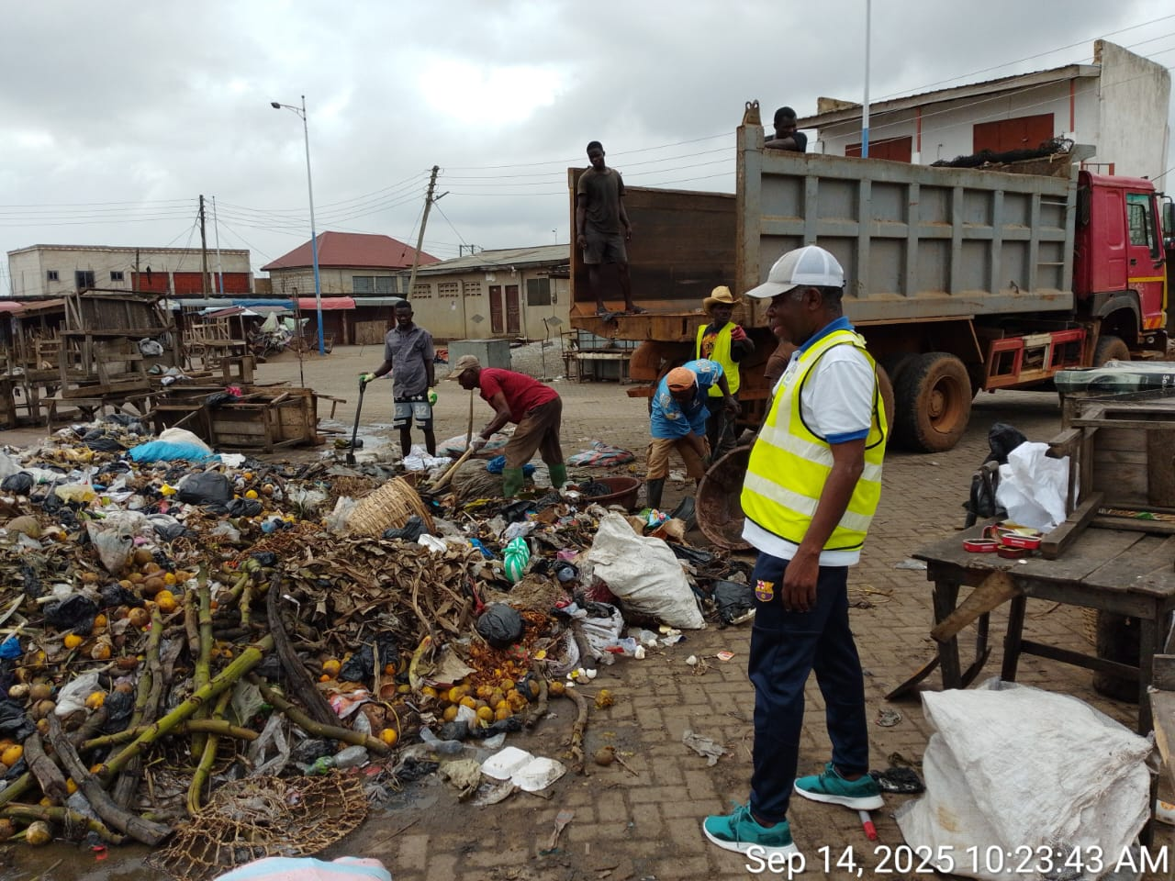
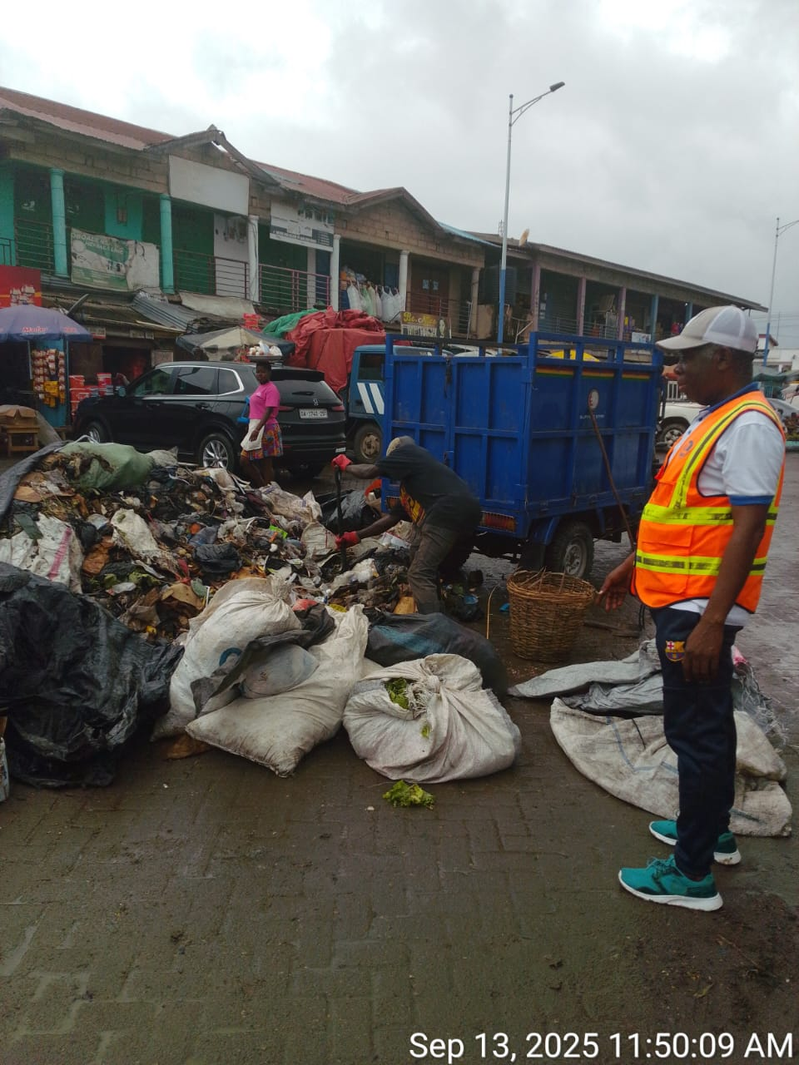
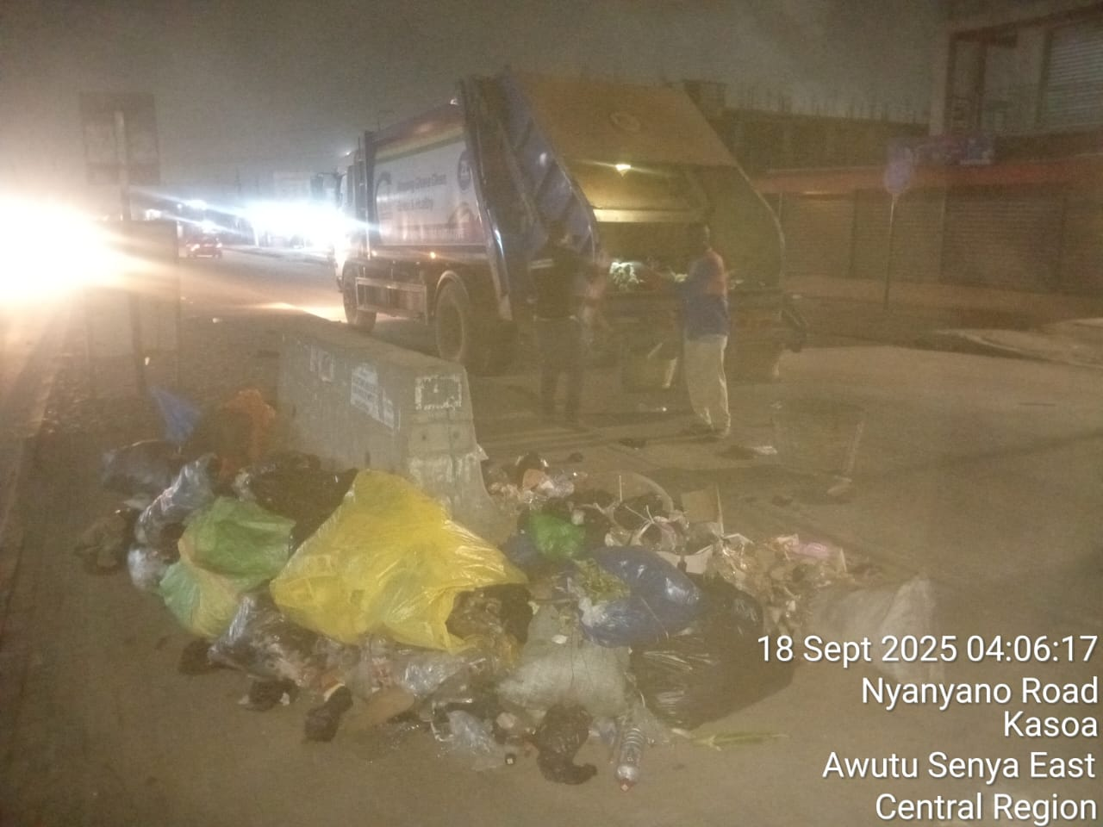
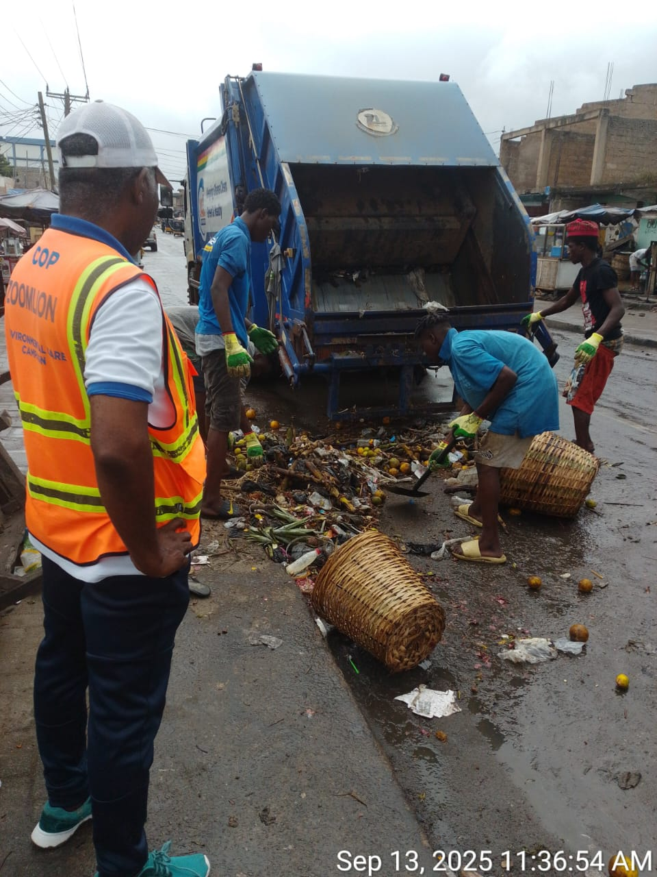
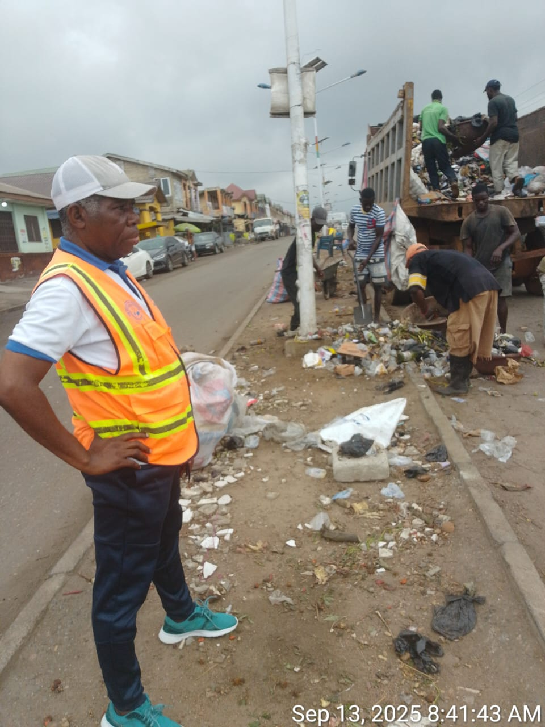
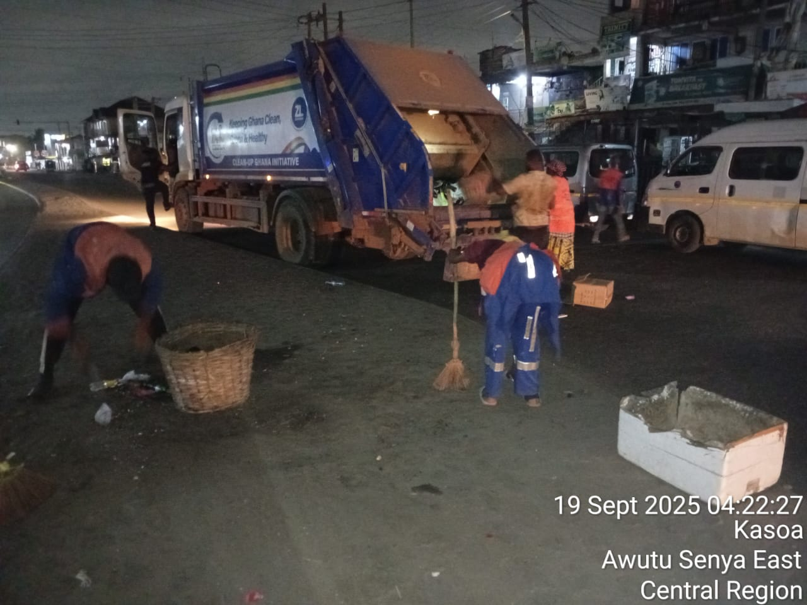
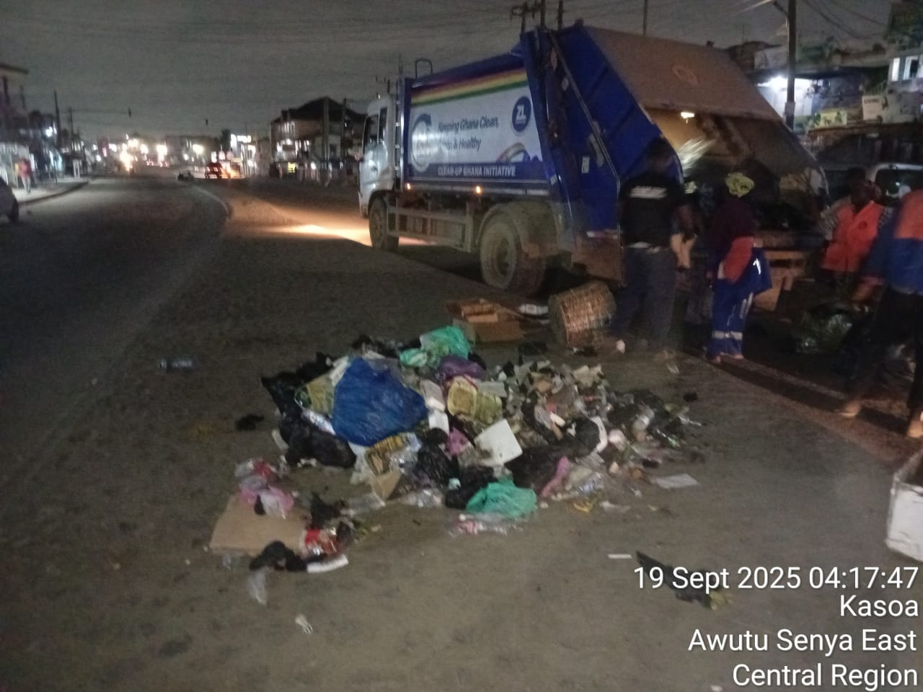
Above Pictures Show Public Cleansing by various Service Providers at the Kasoa CBD and New Market During the Period Under Revie

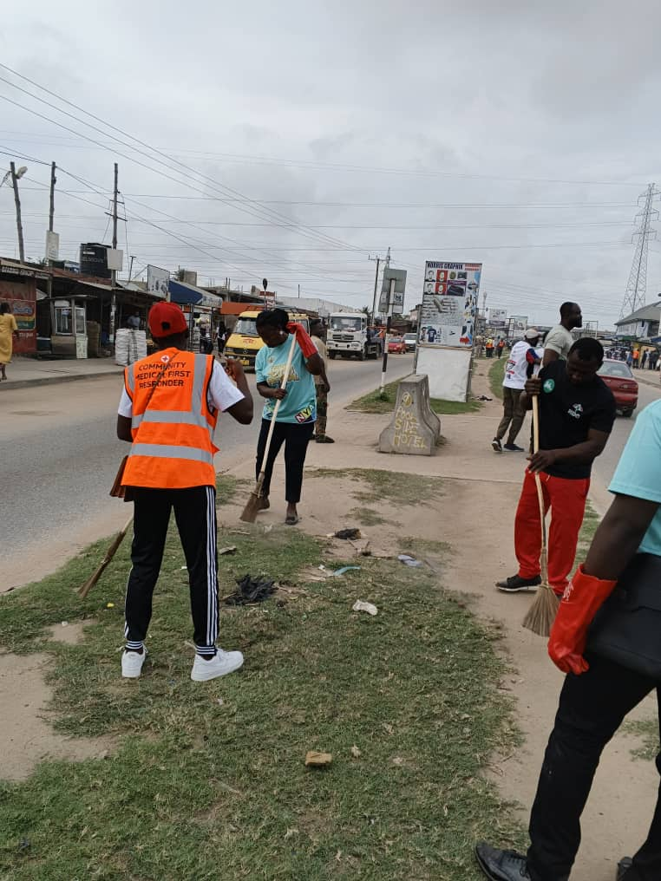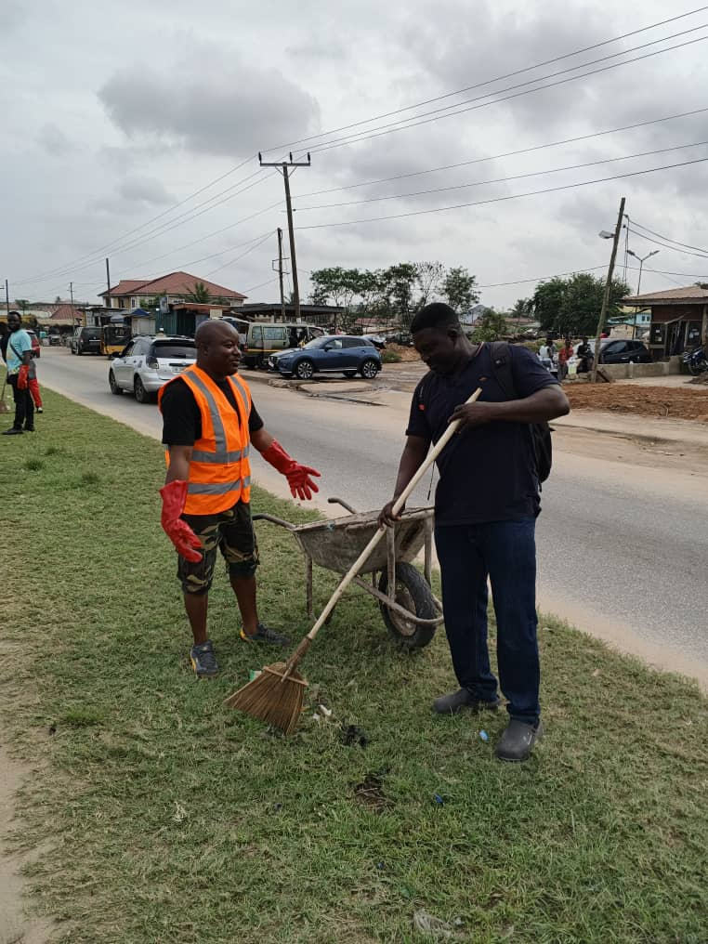
Sweeping along the Nyanyano road during the National Sanitation Day celebration within the Municipality on 8th the November, 2025.

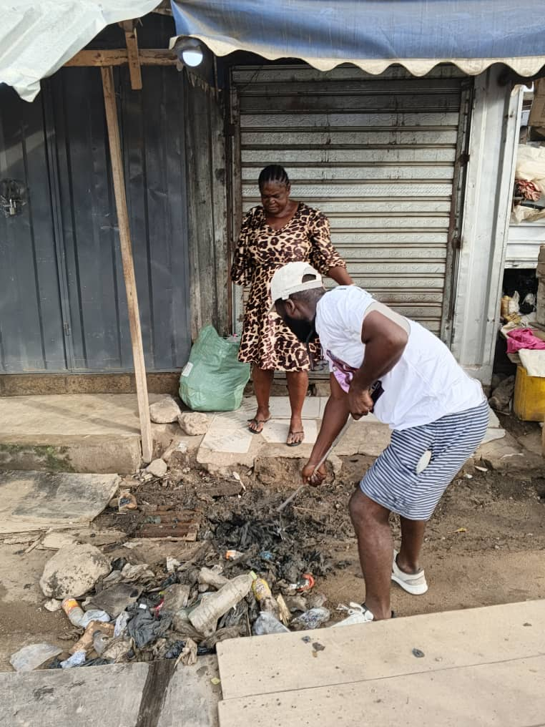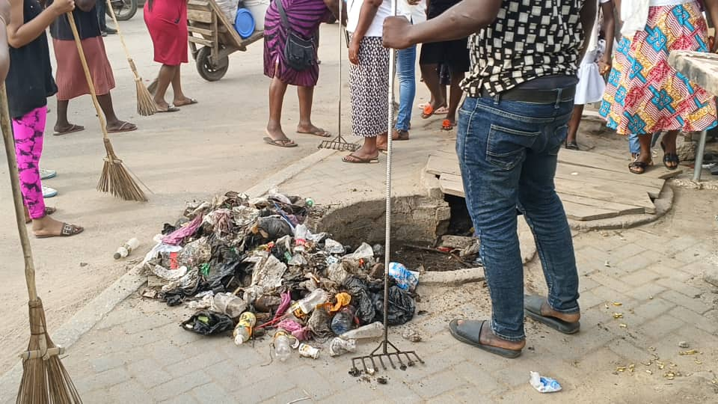
Raking and sweeping along the Nyanyano road during the National Sanitation Day celebration within the Municipality on 8th the November, 2025.

The MEHO and some Hon. Assembly members strategizing to ensure efficient and effective Sanition Day Celebration Clean Up exercise. 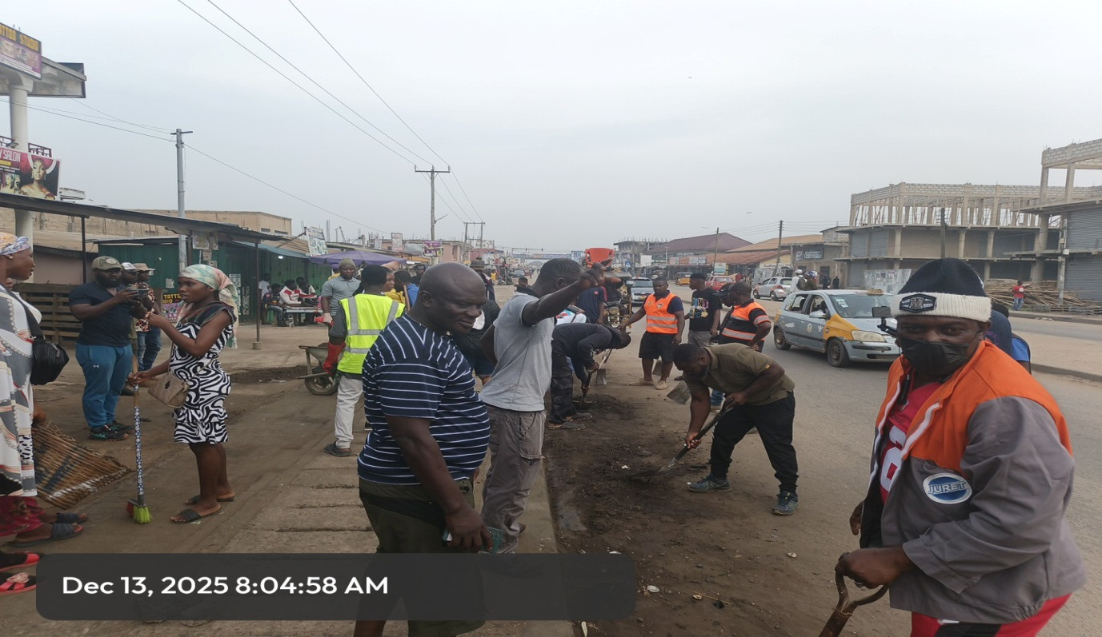 Some stakeholders actively participating in the National Sanitation Day clean up exercise at Kasoa Nyanyano road.

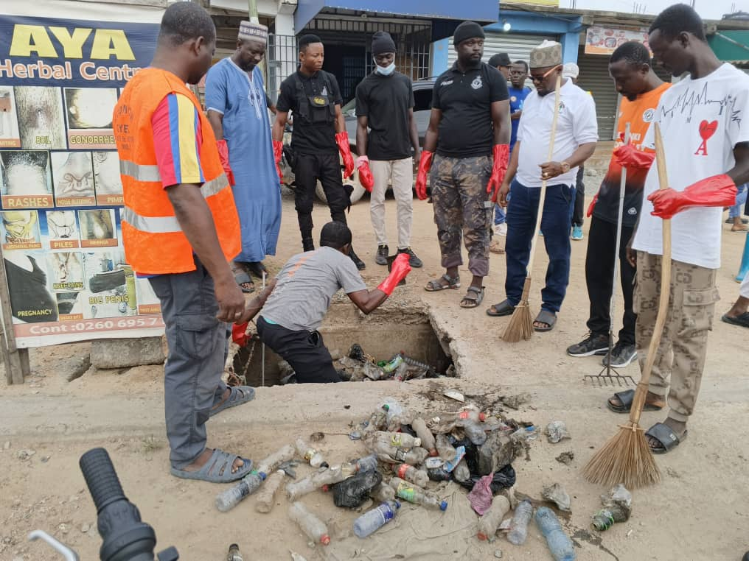
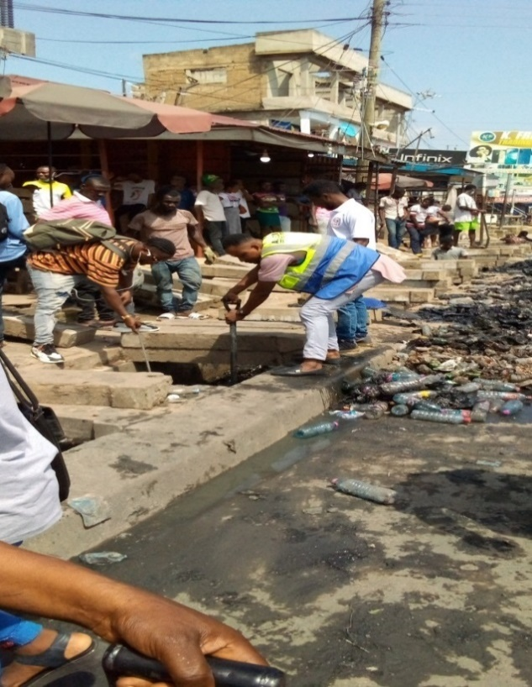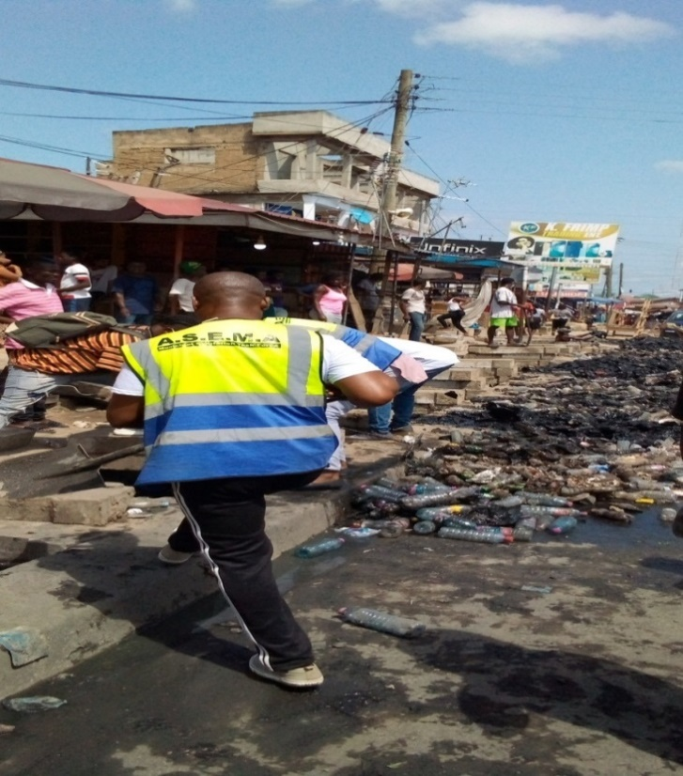

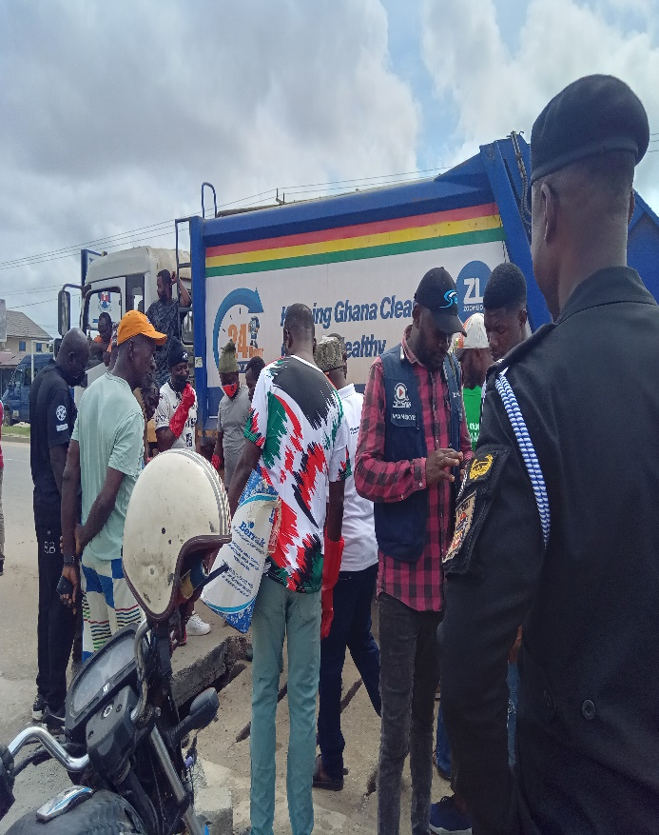


An Environmental Health Staff in Collaboration with NCCE Embarking on Sensitisation During National Sanitation Day Clean up Exercise.

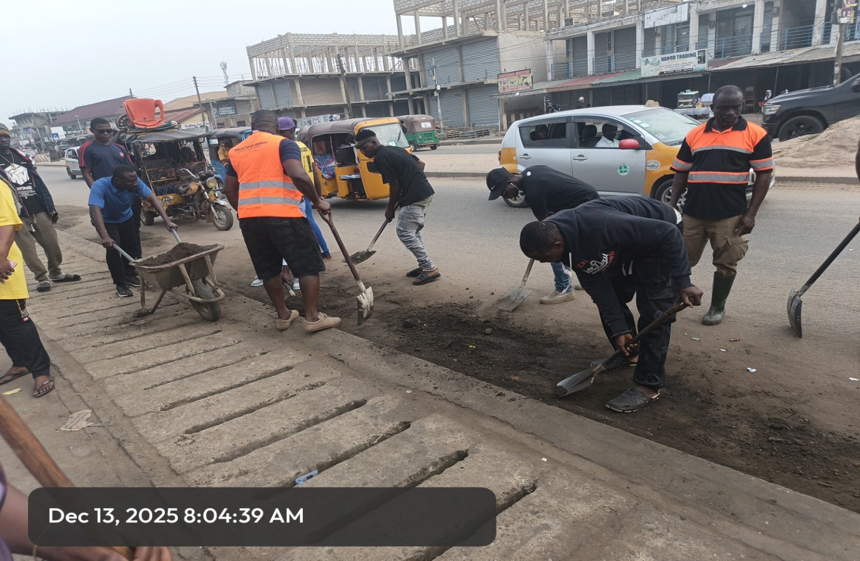

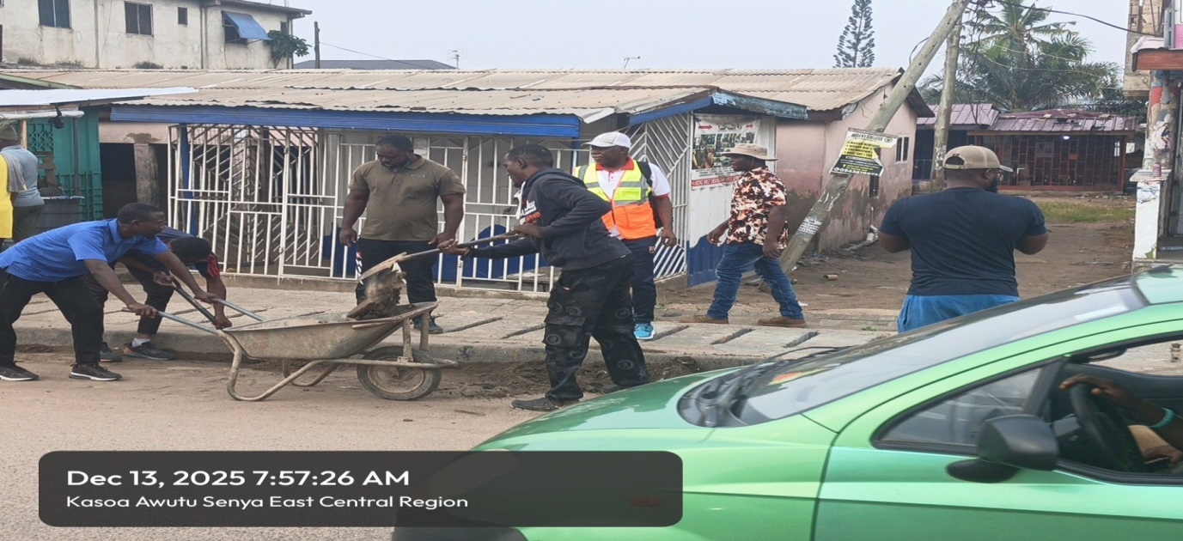
Above Pictures Show National Sanitation Day Clean Up Exercises Collectively Undertaken By Various Stakeholders During the Period Under Review

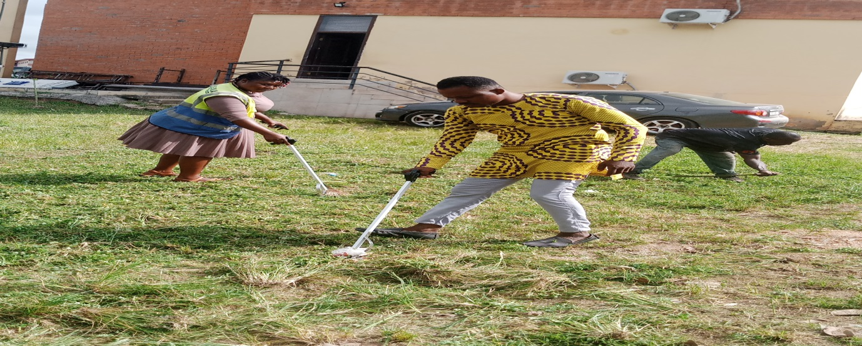

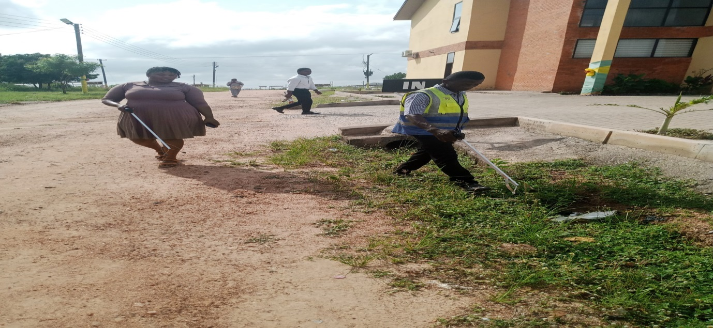
The above Pictures Show Some Staff of the Assembly Embarking on a Clean-up Exercise at the Municipal Assembly Premises.

9. SOLID WASTE MANAGEMENT
With a population of about 243, 600 Awutu Senya East Municipality generated approximately 170.52 tons a day and 62239.80 tons in 2025 based on solid waste generation of 0.7kg per capita per day. In all a total of 44,190 (71%) tons of total waste generated were collected and sent to the final disposal site at Ojobi for safe final disposal. The general condition of the final disposal site was fair as the Private owner regularly at least after every two to three times in a year pushed, levelled, compacted and disinfested the facility to enhance solid waste management in the Municipality

9.1 Clearing of Existing Heaps of Refuse
Aside the monthly supervision of pushing, levelling, compacting and disinfestation of waste at the final disposal site, the Unit also supervised the clearing, evacuation and disinfestation of waste resulting from spill over at the Kasoa New Market container sites on several occasions. This was to ensure a clean, safe, healthy and pleasant physical environment devoid of rats and disease pests and vectors which are incriminated in cross contamination of both edible and non-edible food items in the market’s physical environment. To enhance market sanitation, the Unit at latter part of the year also facilitated a number of clearing of waste at the New Market through the engagement of twenty (20) by-day casual sanitary labourers who swept and cleared waste after every market day.

9.3 Household, Industrial and Commercial Waste Collection
To increase coverage of household, industrial and commercial access to solid waste collection services and thereby reduce the incidence of indiscriminate disposal of solid waste and its associated menace in the Municipality, the Unit during the year under review collaborated with private solid waste collectors operating in the Municipality namely: Coastal Waste Management, Sisbros and Honest Waste Companies in registering a total of One Thousand Five Hundred and One (1,501) cl

9.4 Acquisition of Sanitation Tools
As part of the Assembly’s mandate to ensure enhanced and sustainable sanitation service delivery, the Assembly purchased a number of sanitary tools for distribution to its sanitary labourers for use during market sanitation delivery and clean-up exercises. Sanitary tools purchased were
S№ ITEMS/TOOLS №/QUANTITY PURCHASED
1. Wheelbarrows - 10
2. Brooms - 500
3. Shovels - 15
4. Rakes - 20
5. Filter Masks - 400
6. Hand gloves - 400
7. Disinfectant - 200 litres
8. Insecticides - 200 litres
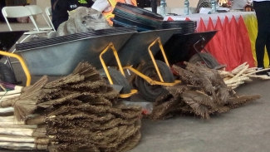
9.5 Acquisition of Additional Refuse Containers
As a way of increasing coverage of communities accessibility to central communal refuse container systems to reduce the rate of dumping elsewhere, the Assembly through Zoom lion Ghana Ltd acquired two additional skip refuse containers which were placed at vantage points in communities which neither had access to door-to-door solid waste collection services nor central communal refuse container system to enhance solid waste collection in those communities.

9.6 Monthly Sanitation Day Exercises (Clean Up Exercise)
As part of the Unit’s conscious efforts to ensure clean, healthy and pleasant physical environment in settlements in the Municipality and as part of efforts to inculcate in the populace the spirit of “Sanitation Day Exercises ( Clean Up Exercises ) at Kasoa Central Business District, the various electoral areas, the Kasoa New Market etc. The Unit facilitated 6 Monthly Sanitation Day Clean up Exercises.
Activities undertaken were
- Desilting of Public Drains
- Hauling of wastes to the final disposal site
- Sweeping,Raking and
- Weeding

10. LIQUID WASTE MANAGEMENT
Disposal of waste water from bath houses and other domestic activities into open spaces in the various settlements with their adverse effects on public health and socio-economy continued to be a menace in the Municipality during the year under review. As a way of managing the situation, the Unit embarked on a number of intensive public education and campaigns to educate and sensitize the populace on the health dangers associated with the menace. This was followed by arrest and prosecution of offenders to serve as deterrent and instil discipline among the populace.
The Unit also supervised dislodging of septic tanks of institutions, households and public toilets.

11. DISEASE PEST AND VECTOR CONTROL
To reduce the incidence of malaria and other pest and vector borne diseases, the Unit during the period under review with funding from the Assembly facilitated a number of disease pest and vector control activities as indicated below
S№ | Activity undertaken | № Undertaken
1. | Mosquito Larvae surveys to map out critical breeding sites in the Municipality | 166
2. | Monthly Clean-up Exercises | 6
3. | Treatment of natural potential breeding sites | 47
4. | Treatment of man-made potential breeding sites | 160
5. | Health Education/Promotion | 44
6. | Treatment (Disinfection and Disinfestation) of public toilets and refuse dumps | 262
7. | Desilting of public drains in bigger settlements and CBD | 8
8. | Derating of New and Old Markets | 0
11 | Disinfection of Kasoa New and Old markets | 0
12 | Disinfestation Kasoa New and Old markets | 4

12. MARKET SANITATION
Market sanitation plays a significant role in determining the socio-economic and health status of a country since the investment in unsanitary environment leads to contamination of both edible and non-edible items and its associated upsurge of diseases and high expenditure of treatment of such diseases. In light of this, the Unit during the period of reporting facilitated a number of clean-up exercises in Kasoa New Market to enhance sanitation. The Unit also facilitated a special clean-up exercise initiated by the Hon. Municipal Chief Executive at the later part of the year. Activities undertaken during the exercises were
- Sweeping and raking of wastes
- Collection of waste
- Hauling of wastes to the final disposal site
- Desilting of public drains
- Dislodging of drains
- Sanitation education and campaign to sensitize the populace and
- Enforcement of the Assembly’s market sanitation bye-laws.

13. ENVIRONMENTAL MONITORING AND STANDARDS ENFORCEMENT AND HOUSEHOLD LATRINE PROMOTION
As part of the Unit’s conscious efforts to ensuring clean, safe, healthy and pleasant physical environment in all settlement in the Municipality, the Unit carried out a number of environment monitoring and standards enforcement activities. These are
- Visits to some communities like Ofaakor, Zongo, Adakope, Kpormetey and Adam Nana to address issues like connection of faecal sludge and effluent openly into nearby drains and open spaces
- Visits to privately owned public toilets to address poor hygiene and sanitation problems
- Night patrol to call to order dumping of waste along major roads/streets and drains in the Municipality by unscrupulous people
- In line with the Sustainable Development Goal (SDG) 6, the Unit in collaboration with the Assembly’s Development Control Team made up of the Works Department and Physical Planning Department also ensure that all household toilets indicated in approved residential building permits were actually constructed and put into use. In all 1,550 private (household) toilets facilities made up of 1050 VIP household latrines and 500 WC facilities were approved as being safe for use by the household.

14. HEALTHCARE FACILITY SANITATION
Healthcare facility sanitation plays an important role in preventing nosocomial infections. In view of this and as a way of ensuring clean, safe, healthy and pleasant physical environment at healthcare facilities which were mostly private clinics the Unit undertook the following activities;
- Ensuring of sanitary disposal of infectious materials such as surgical, obstetrical and pathological wastes by incineration
- Sanitary disposal of renal dialysis waste, laboratory wastes, discarded serums and vaccines that have not been autoclaved, syringes, needles, placenta etc. by incineration
- Supervision of clinic sanitary labourers and orderlies and
- Supervision of sanitary disposal of liquid waste
15. SCHOOL HEALTH PROGRAMME
The Unit in collaboration with the SHEP Co-ordinator of Ghana Education Service (GES) organised hygiene and sanitation education and training programmes during which basic school children of some selected schools were trained as agents of Hygiene Behavioural Change. Issues highlighted on were
- Personal hygiene with emphasis on hand washing with soap under running water and
- Environmental Sanitation
Find below outcome of the programmes.
- Number of both private and public basic schools educated/trained - 140
- Number of lectures/talks given - 120
- Total number of basic school children trained - 4000

16. HEALTH EDUCATION/PROMOTION
As part of the Unit’s commitment to preventing Water, Sanitation and Hygiene (WASH) related diseases among ten top diseases recorded by Ghana Health Service and to promote community health, the following health educational programmes were undertaken during the period under review
S№ | Title of Education Programme | Date | Community | № Of Participants
 |  |  |  | Male | Female
1. | Hygiene education in relation to typhoid fever prevention | 10-1-25 | New Town | 125 | 175
2. | Ensuring clean environment through proper waste disposal practices | 4-2-25 | Zongo | 71 | 150
3. | The dangers associated with allowing animals to stray | 10-3-25 | Adam Nana | 150 | 171

S№ | Topic for education programme | Date | Community | № of Participants
 |  |  |  | Male | Female
1. | Enhanced and sustainable public toilet management | 16-4-25 | Lamptey Mills | 17 | 11
2. | The dangers associated with poor hygiene practices of food vendors | 12-5-25 | Ada Korpe | 23 | 253
3. | Hand washing with soap under running water; a recommended healthy lifestyle | 13-6-25 | Kpormetey | 150 | 190

S№ | topic for Education Programme | Date | Community | № of Participants
 |  |  |  | Male | Female
1. | Control and Prevention of Cholera | 8-7-25 | Akweley | 88 | 150
2. | Control and Prevention of Cholera | 5-8-25 | Walantu | 61 | 133
3. | Control and Prevention of Cholera | 10-9-25 | New and Old Market | 45 | 135

S№ | Topic for Education Programme | Date | Community | № of Participants
 |  |  |  | Male | Female
1. | Control and Prevention of Cholera | 7-10-25 | Amuzu Korpe | 55 | 76
2. | Control and Prevention of Cholera | 11-11-25 | Kasoa New and Old Market | 150 | 297
3. | Control and Prevention of Cholera | 16-12-25 | Kasoa Zongo | 250 | 367

16.1 Control and Prevention of Cholera
Following the Cholera outbreak in the previous year (2024) during which the Municipality had its due share, the Unit during the period under review intensify Cholera prevention activities as follows
- Cholera Risk Communication in Communities, Schools, Churches, Mosque, Lorry Terminals, Markets, Chopbars, Water Factories, Restaurants etc.,
- Ensuring of observance of Hygiene Protocols at Kasoa Polyclinic where all victims were sent to for management.
- Disinfection of Kasoa Polyclinic and Mother and Child Hospital
- Disinfection of vehicles that carry victims to Kasoa Polyclinic.
- Contact tracing and disinfection of homes of victims
- Dignified burial of cholera dead bodies
- Disinfection of possible sources of infection.

The Unit also embarked on disinfection and disinfestation exercises and enforcement in the Municipality.
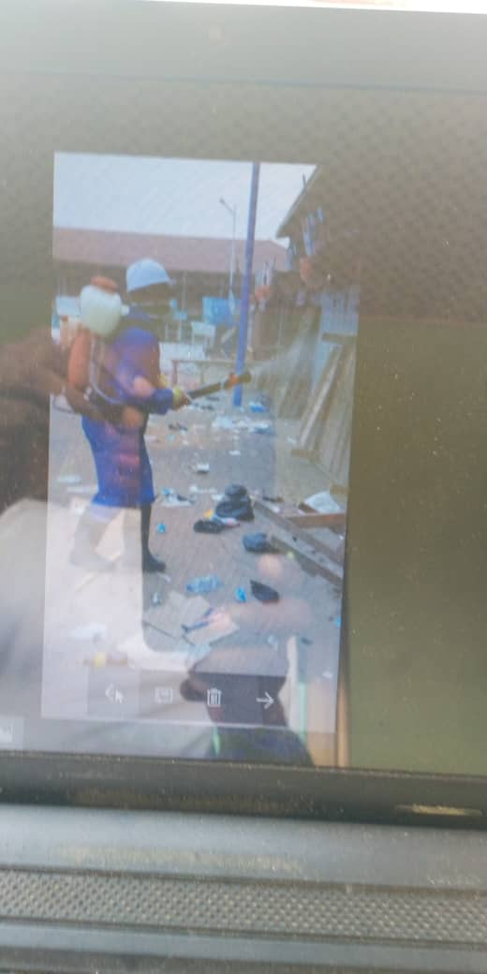
Fumigation at the Kasoa old market, 19th March, 2025
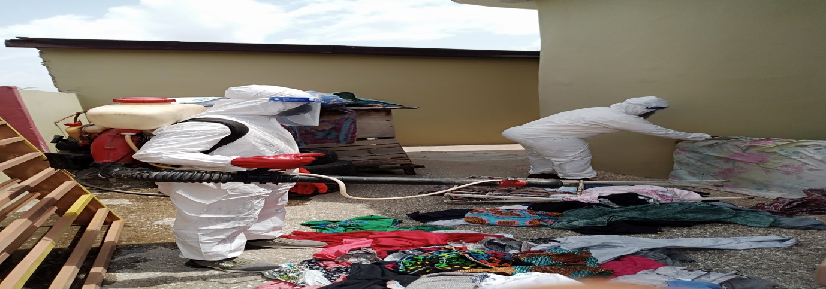
Disinfection of Hotel on 18th June, 2025 at Akweley
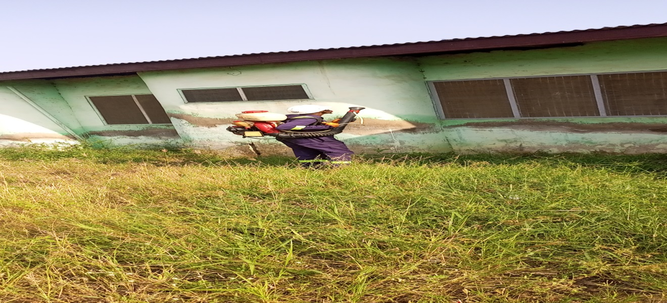
Disinfestation a house at Kasoa New Town 17th June, 2025.
18. ENVIRONMENTAL MONITORING, STANDARDS ENFORCEMENT AND HOUSEHOLD LATRINE PROMOTION
As part of the Units conscious efforts to ensure clean, safe. Healthy and pleasant physical environment in all settlements in the Municipality, the Unit carried out a number of environmental monitoring, standards enforcement and household latrine promotion activities. These included
1. Visits to some communities like Zongo, Ofaakor, Adakope, Kpormetey and Adam Nana to address issues like connection of faecal sludge and effluent openly into nearby drains and open spaces
2. Visits to privately owned public toilets to address poor hygiene and sanitation problems
3. Night patrols to call to order unscrupulous people dumping waste along major roads and streets and into drains in the Municipality.
4. In line with the Sustainable Development Gaols (SDG)-6, the Unit in collaboration with the Assembly’s Development Control Team made up of the Works Department and Physical Planning Department also ensured that all households toilets indicated in approved development permits were actually constructed and put into use. In all 1,472 private (Household) toilet facilities made up of 871 VIP household latrines and 601 WC facilities were approved as being save for use by the respective households
Percentage of household latrine increment from 2024 to 2025
= (11,453-9,301) × 100
9,301

= 1,472 × 100
9,301= 15.83%
This is an increase of 15.83% in number of household toilet facilities over the 9,301 baseline of 2024
Population in 2024=243,601
Population in 2025=244,660
Household Population with access to basic Sanitation in 2024 =29,232
Household Population with access to basic sanitation in 2025 =38,538
Percentage increase in household population with access to basic sanitation from 2024 to 2025 =(38,538-29,232 )*100
29,232
=32%

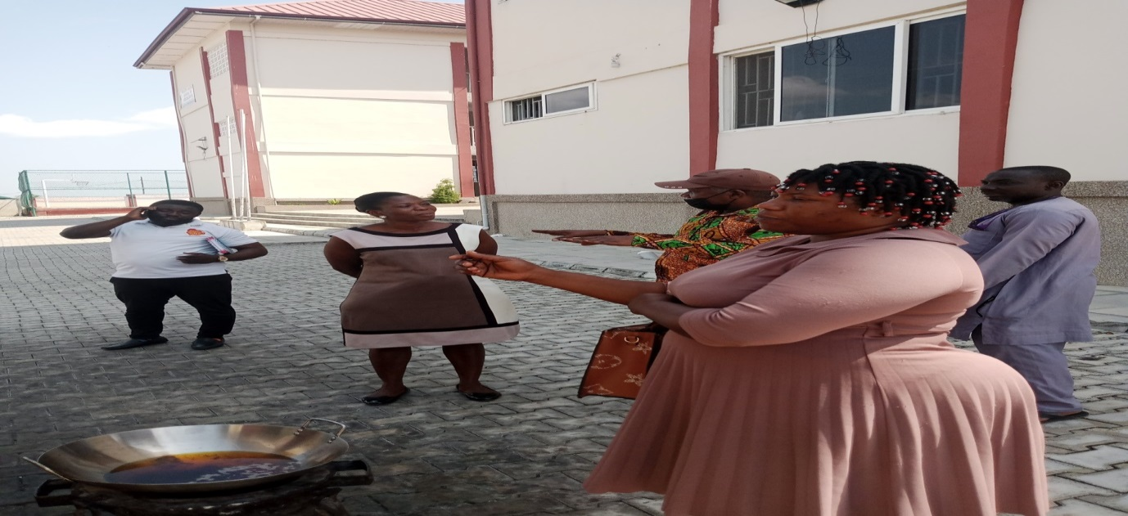

Public Education on Standards enforcement by Environmental and Sanitation Sub Committee led the MEHO (Mr Godson M Lodo) at Kasoa Gada on 14th July, 2025.

2024 BASIC SANITATION COVERAGE
Urban | 66%
Rural | 60%
Municipality=63%

19. ENVIRONMENTAL ENHANCEMENT PROGRAMS
The department during the period under review embarked on the following activities to ensure a clean, safe, pleasant and healthy environment.
1. Noise Pollution Control
2. Environmental education and
3. Afforestation
Table Showing Noise Making Complains Received and Addressed in 2025
S№ | Name of Complainant | Contact № | Location | Remedial Actions taken
1 | Mohammed Yartey | 0246420086 | Little-Rock Police Station | Defendant’s noise making machines were calibrated to conform to the noise permissible levels of the Assembly’s Noise Abatement Bye-Laws, 2018
2 | Paulina Kumi | 0243032310 | Kamebre | Defendant’s noise making machines were calibrated to conform to the noise permissible levels of the Assembly’s Noise Abatement Bye-Laws, 2018
3 | Cornelius Worlanyo K.D | 0244591764 | Opeikuma Junction | Defendant’s noise making machines were calibrated to conform to the noise permissible levels of the Assembly’s Noise Abatement Bye-Laws, 2018
4 | Ramatu Ali Gariba | 0543496365 | Oklunkwanta | Defendant’s noise making machines were calibrated to conform to the noise permissible levels of the Assembly’s Noise Abatement Bye-Laws, 2018
5 | Timothy Baidu Jones | 0243746378 | Agyenkwa Dr Jesus | Defendant’s noise making machines were calibrated to conform to the noise permissible levels of the Assembly’s Noise Abatement Bye-Laws, 2018
6 | Eric Addo | 0243362287 | Kaemebre | Defendant’s noise making machines were calibrated to conform to the noise permissible levels of the Assembly’s Noise Abatement Bye-Laws, 2018
7 | Emmanuel | 0273557348 | Tipper -Kasoa | Defendant’s noise making machines were calibrated to conform to the noise permissible levels of the Assembly’s Noise Abatement Bye-Laws, 2018

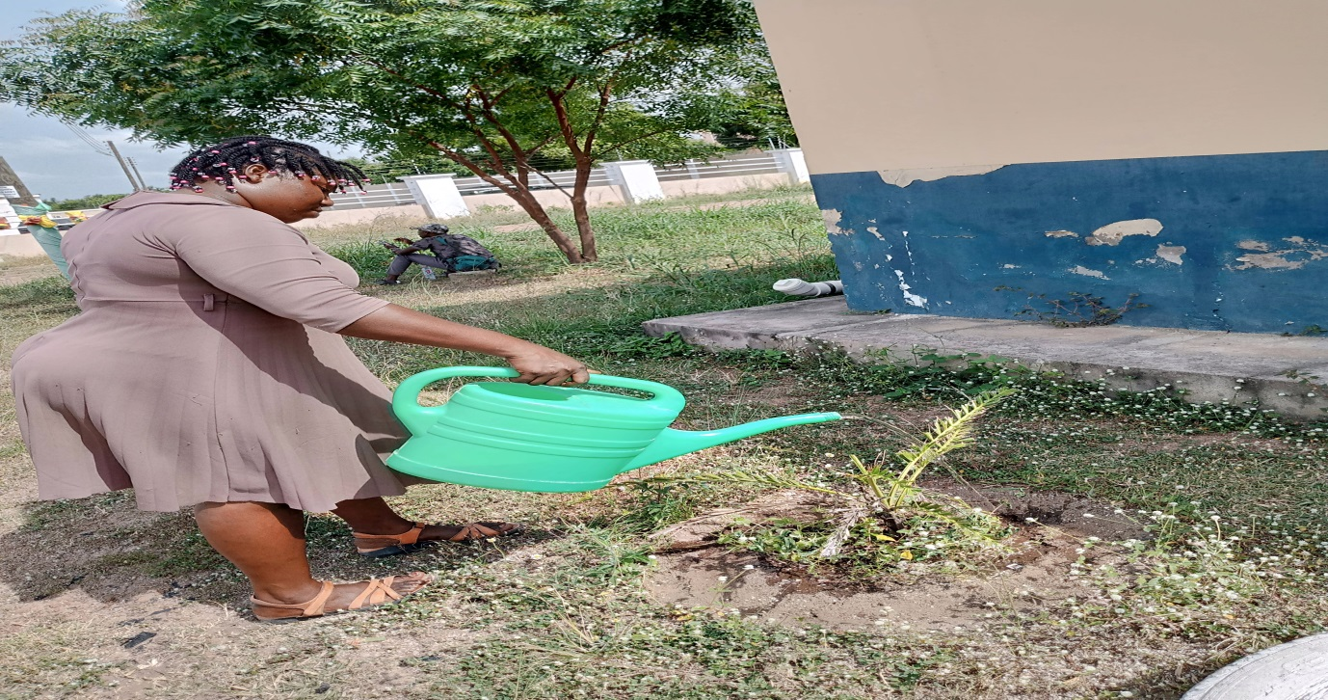
Watering of Tree by Environmental Health Staff on The Assembly’s Premises as Part of the Assembly’s Reforestation Program on 28/11/2025.

20. TOURISM RELATED ACTIVITIES
To enhance the hospitality industries and consequently promote tourism in the municipality, the Unit undertook the following activities;
1. Inspection of Hotels, restaurants, and guest houses.
2. Education of Hoteliers and
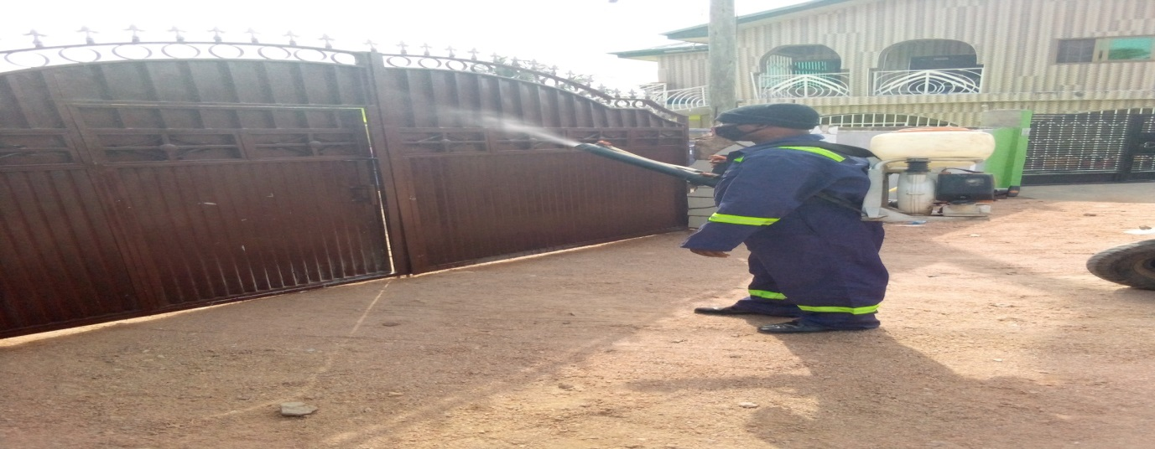
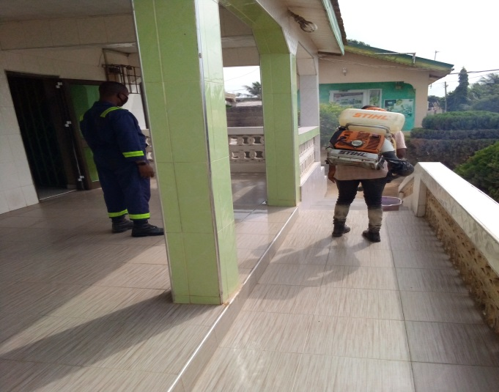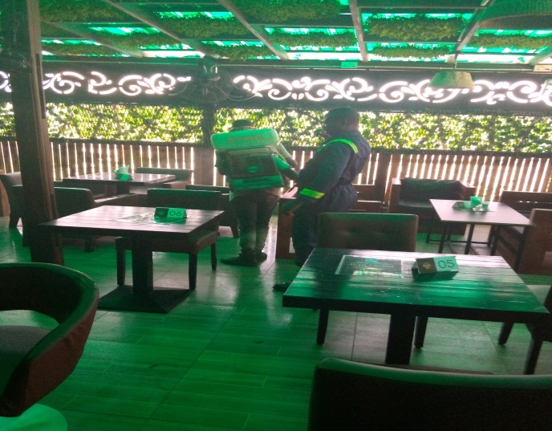
Fumigation of Hotels and Restaurants

21. RESEARCH ACTIVITIES
In pursuant of increasing coverage of household access to household latrine facilities, communal refuse container and door-to-door solid waste collection services in the Municipality, the Unit conducted studies in Adakope, Zongo and Kpormetey communities. Other researches carried out include:

- Research into contributing factors which leads to the prevalence of communicable diseases like Typhoid fever at Kpormetey.
- Research into household’s inability to pay for door-to-door solid waste collection services at Adakope
- Mosquito larvae surveys throughout the Municipality.

22. INTERAGENCY COLLABORATION
The Unit collaborated with other agencies as follows;
S№ | COLLABORATING AGENCY | AREA OF COLLABORATION (PROGRAMME)
1. | Ghana Education Service | School Health Inspection and Training of basic school children as agents of Hygiene Behavioural Change
2. | Zoomlion Company Ltd | Management of Sanitation Improvement Package (SIP)
3. | Sisbros Waste Company, Honest Waste Company, Alliance Waste Company, Atalix Waste Company,Network Waste Company,Zoom Lion company and Coastal Waste Company | Door-to-door solid waste collection service
4. | Ghana Health Service | Cholera Control and Prevention Education
5. | Community Based Organiations(CBOs) | Sanitation Advocacy
6. | Promise Consortium,Trend and Accra School of Hygiene | Food Safety and Hygiene Project
7. | Respective Hon. Assembly Members, NADMO and Task Force, Security Personnel, Chief Iman, Local Council of Churches YEA Zoomlion Ghana Limited etc. | Monthly National Sanitation Day clean-up exercises
8. | Diagnostic Center, FDA and OLAM | 2025 Annual Mandatory food/drink vendors’ health screening and certification and Food Hygiene and Safety Education.
9. | Veterinary Services Department | Slaughter House Duties

23. REVENUE MOBILIZATION
Revenue mobilization plays an important role in the development of every Metropolitan, Municipal and District Assembly (MMDA) in Ghana. In view of this, the Unit during the period under review generated a total of Two Hundred and Fourteen Thousand Six Hundred and Fifty-One Ghana Cedis (GHȻ 214, 651.00) as indicated below.
Sno. | Revenue Item | Amount Generated
1 | Health Certificates | Ghc202,180
2 | Slaughtering Fees | Ghc12,471
 | Total Amount | Ghc214,651

24. CONSTRAINTS AND CHALLENGES
The following constraints and challenges did not only negatively affect the performance of the Unit during the period under review, but also they impacted adversely on the general sanitation situation in the Municipality. They included the following:
- The populaces’ negative attitude and apathy towards environmental sanitation
- Inadequate means of transport to monitor and supervise sanitation service delivery and
- Woeful inadequate Environmental Health staff and sanitation labour force.The World Health Organization (WHO) recommends Environmental Health Officer to Population Ratio of 1:700.With a population of about 243,600 ASEM by calculation should have Environmental Health Staff Strength of 348. With the current staff strength of 21 ,this implies there is a staff deficit of 327
- Inadequate Prosecuting Officers

25. ACHIEVEMENTS
- The Unit during the period under review was very instrumental in lead facilitating Cholera Risk Communication and related activities in communities, schools, lorry parks, churches, markets, eateries and other public spaces in the municipality.
- The Unit was able to strengthen the working relationship between the Assembly and Sanitation service providers working in the Municipality through Environmental Health Staff and Stakeholders performance review meetings
- The Unit was able to strengthen the partnership between the Assembly and fifty managements of privately owned public toilets across the Municipality for an enhanced and sustainable public toilet management system.
- The Unit was able to sustain the monthly clean-up exercise
- The Assembly has bought 3 new refuse skip containers

26. CONCLUSION
The Environmental Health and Sanitation delivery in the Municipality as per activities mentioned above involved multi scientific, technical, economic and social interventions. No one or single intervention will be able to control all the sanitation problems as effectively as comprehensive programs based on national and international policies. Governments and other representatives at the grassroots level own it as a responsibility to consistently and consciously champion the course of sanitation interventions contained in their party manifestoes since their performance over the mandated period will be judged according to their sanitation policies, programmes and manifestoes.
The following recommendations if implemented to the letter could go a long way to help government and for that matter local government (Awutu Senya East Municipal Assembly) deliver on its manifestoes.
27. RECOMMENDATIONS
The following are strongly recommended to enhance the Unit’s performance in subsequent years
- The Assembly should establish active co-operation with other support agencies (CBOs, NGOs etc.) working in the environmental sanitation sector and examine ways of developing partnership between their programmes and those of the Assembly for mutual benefits with the Environmental Health Unit playing a co-ordinating role
- That the Assembly should adequately resource the Unit to carry out activities aimed at accelerating the attainment of Sustainable Development Goals (SDG) and other sanitation development policies
- That the Assembly should not hesitate to provide the Unit with logistics such as motor bikes that will enable it champion the course of Community Led Total Sanitation (CLTS) to attain Open Defecation Free (ODF) community in the Municipality
- That as a policy directive the Assembly should continue to encourage Public Private Partnership (PPP) in the area of construction of public toilets at lorry terminals and market areas and through the Unit encourage households to construct household latrines at their cost
- That as a way of supplementing communal refuse container system, the Assembly through the Unit should encourage more private solid waste companies to come and operate in the Municipality
- That the Assembly through the Unit should consider other solid waste management options namely source separation, composting and waste to renewable energy as a way of adding value to waste

28. PLANNED ACTIVITIES AND TARGETS FOR 2026
As part of the Unit’s conscious efforts to improve Environmental Health and Sanitation delivery in the Municipality, the following targets have been set for 2026.
- To organise and facilitate 6 stakeholders consultative and sensitization meetings.
- To organise and lead facilitate 12 Monthly National Sanitation Day clean-up and Operation Clean Your Frontage exercises and sanitation campaigns in all the 6 Zonal Councils, Kasoa New and Old Markets.
- To build capacity of 3000 institutional food/drink handlers on food/drink safety, hygiene and nutrition.
- To prosecute 120 sanitary offenders across the Municipality
- To educate and persuade 350 households to construct one household latrine each
- To educate and persuade 11,000 food/drink vendors across the Municipality to register and undergo 2026 annual mandatory food/drink vendor’s health screening and certification.
- To inspect 26,000 premises comprising private and public basic schools, bakeries, eating bars, drinking bars, hotels, guest houses, domiciliary, restaurants, public toilets, clinics, water producing factories, etc.
- To collaborate with the Assembly’s registered solid waste companies operating in the Municipality in registering 3,700 new clients.
- To intensify Cholera Risk Communication and Hygiene Promotion in the Municipality.

APPENDIX 1
S/N | INDICATOR | 2021 | 2022 | 2023 | 2024 | 2025
1.0 | Population | 236,527 | 243,150 | 249,958 | 256,957 | 264,152
 | Population with to access to  sanitation (Toilet Facility)  Water Closets: Biodigester  Septic Tank  KVIP  VIP | 4,783  22,535  8,156  10,812 | 6,638  23,561  8,169  11,112 | 7,099  24,246  8,299  12,023 | 7,811  24,848  8,068  12,771 | 9,008  25,200  8,162  13,366
 | Total population with access to  Basic sanitation | 46,286 | 49,480 | 51,667 | 53,498 | 55,736
 | Percentage of Population with  access to sanitation  Water Closets: Biodigester  Septic Tank  KVIP  VIP | 2.02  9.53  3.44  4.57 | 2.73  9.69  3.36  4.73 | 2.84  9.70  3.32  4.81 | 3.04  9.67  3.14  4.97 | 3.41  9.54  3.09  5.06
 | Percentage of Population with  access to Basic sanitation (Municipal) | 19.57 | 20.35 | 20.67 | 20.82 | 21.10

Source: Awutu Senya Municipal Assembly (Development Planning and Environmental Health & Sanitation Unit), February 2026

2. VOLUME OF SOLID WASTE GENERATED AND DISPOSED OFF.

INDICATOR | NUMBER(VOLUME)
Population | 243,600
Volume of waste generated in tons daily | 170.82 tonnes
Volume of waste collected and disposed off safely weekly | 44,413.75 tonnes
Percentage of waste collected and safely disposed off weekly | 71%

3.DIRECTORY OF LATRINE ARTISANS
SNO | NAME OF ARTISAN | NAME OF COMPANY | CONTACT/GPS
1 | EMMANUEL AZIANOGBE | PLAZICON VENTURES | 0546423221  (CX-146-3745)
2 | FELIX GALLO-AGYEI MAWUTOR | VICTORY LINK ENTERPRISE | 0244161789
3 | CHARLES AHAFIA | ST. JAZEERA TECHNOLOGIES | 0208441830
4 | SHADRACK YEBOAH | WOFA K. LIMITED | 0540706729  (CX-212-5205)
5 | JOSEPH NARTEY | SABIS COMPANY LIMITED | 0550305292
6 | FREDRICK AZIANOGBE | LEGEND ARCHITECTURE  DESIGN &CONSTRUCTION COMPANY LIMITED | 0549705477  (CX-146-3745)
7 | JOHN ABOTSI | ABOTSI PLUMBING SERVICES | 0599447747
8 | MASTER AMOS | KINGS OF KINGS PLUMBING WORKS | 0546476241

4.DIRECTORY OF SOLID WASTE SERVICE PROVIDERS

SNO | NAME OF SERVICE PROVIDER | CONTACT NUMBER | OPERATIONAL AREA(S)
1 | Coastal Waste Management Services | 0242014094 | Iron City,Kaemebre,Ash Town,Down Town,Akweley
2 | Ataliz Services | 0244819869 | CP/Winger
3 | Honest Waste | 0204343750 | Opeikuma
4 | RKM Waste | 0244384431 | Adam Nana
5 | Network Collection Services Ltd. | 0242768417 | Otamens,Joemends.Kpormetey
6 | Rural Waste | 0244792980 | Walantu/Tophill,New Town
7 | Yadah Beyond | 0202677709 | American Town
8 | Ameg Waste And Environmental Services Ltd | 0244238334 | Ofaakor
9 | GNE Waste | 0554354836 | Zongo

5.DIRECTORY OF LIQUID WASTE SERVICE PROVIDERS
SNO | NAME OF SERVICE PROVIDER | NAME OF COMPANY | CONTACT NUMBER
1 | ERIC OPARE | GOD FIRST WASTE | 024933482
2 | JULIUS AMEDZO | WHITE STAR WASTE | 0243483329
3 | PATRICK NYARKO | NYARKO WASTE | 0244098686
4 | ISAAC FIAGAH | ISSACO WASTE | 0249328001
5 | YAW BOAKYE | Y.B WASTE | 059116998
6 | ALEX YARTEY | YARTEY WASTE | 0550026044
7 | EXEKIEL KUSEITU | EASY WASTE | 0246180480
8 | JAMES AGOR | J.A, WASTE | 0547894604
9 | KOFI AMANING | RASTA WASTE | 0244034622S
10 | EMMANUEL BAIDU | BAIDU WASTE | 0556281382
11 | PHILIP ESSUMAN | TOP TEN WASTE | 0244674466
12 | KWABENA SAMPSON | SAMPSON WASTE | 0547911820
13 | SHAIBU YAHAYA | SHAIBU WASTE | 0242777276
14 | ADAMU KADIR | K. KADIR WASTE | 0246561261
15 | MOHAMMED LAMPTEY | LION WASTE | 0243943042
16 | SULLEY IBRAHIM | IBRAHIM WASTE | 0266350208
17 | ABU OSMAN | OSMAN WASTE | 0241172390
18 | KWESI ANTHONY | ANTO WASTE | 0546444416
19 | RAPHEAL AMONOO | AMONOO WASTE | 0241342539
20 | KWABENA AMPADU | AMPADU WASTE | 0276151331

- LIST OF COMMUNAL SKIP REFUSE CONTAINER SITES
SNO | LOCATION | GPS | APPROVED | UNAPPROVED
1 | ODUKPONKPEHE | CX-000-6646 | **********
2 | OLD MARKET TERMINAL | CX-000-5580 | ***********
3 | MENZGOLD OKRUDU | CX-003-0875 |  | *************
4 | ADAM NANA POLICE POST | CX-041-6209 | **********
5 | NEW MARKET CHARCOAL DEPOT | CX-030-4091 | ***********
6 | NEW MARKET AGBELIMA AREA |  | **********
7 | OFAAKOR ALICO ROAD | CX-169-5280 | **********

AWUTU SENYA EAST MUNICIPAL ASSEMBLY
GHANA EDUCATION SERVICE DIRECTORATE
- DATA ON BASIC PUBLIC SCHOOLS ACCESSIBILITY TO WATER AND SANITATION FACILITIES AS AT 15STDECEMBER, 2025
(Tick (√) if available and (x) if not available)

S/N | NAME OF PUBLIC SCHOOL | ACCESSIBILITY OF WATER FACILITY
S/N | NAME OF PUBLIC SCHOOL | AVAILABILITY OF WATER | AVAILABILITY OF INSTITUTIONAL LATRINE | REMARKS
1 | AKWELEY ST. MARY’S ANG. BASIC A | √ | √
2 | AKWELEY ST. MARY’S ANG. BASIC B | √ | √
3 | AKWELEY ST. MARY’S ANG. PRY & JHS C | √ | √
4 | AKWELEY ST. MARY’S ANG. PRY & JHSD | √ | √
5 | ST.MARTHA’S CATHOLIC BASIC A | √ | √
6 | ST.MARTHA’S CATHOLIC BASIC B | √ | √
7 | ICODEHS BASIC SCH | √ | √
8 | NAHADATU ISLAMIC BASIC A SCH | √ | √ | SPOILT BOREHOLE
9 | NAHADATU ISLAMIC BASIC B SCH | √ | √ | SPOILT BOREHOLE
10 | OFAAKOR M/A BASIC SCH A | √ | √
11 | OFAAKOR M/A BASIC SCH B | √ | √
12 | OFAAKOR M/A BASIC SCH C | √ | √
13 | OFAAKOR M/A BASIC SCH D | √ | √
14 | KWAOBONDZIE ALL SAINT ANGLICAM BASIC | √ | √
15 | GADA BASIC A SCH | √ | √
16 | GADA BASIC B SCH | √ | √
17 | METHODIST BASIC SCH A | √ | √
18 | METHODIST BASIC SCH A | √ | √
19 | ODUMPONKPEHE AME ZION BASIC A | √ | √
20 | ODUMPONKPEHE AME ZION BASIC B | X | √
21 | ODUMPONKPEHE M/A ZION BASIC A | √ | √
22 | ODUMPONKPEHE M/A PRY & JHS ZION B | √ | √
23 | OPEKUMA KUMBE ISLAMIC A BASIC | √ | √ | SPOILT BOREHOLE
24 | OPEKUMA KUMBE ISLAMIC B BASIC | √ | √ | SPOILT BOREHOLE
25 | OPEIKUMA ST PETER’S ANG BASIC A | √ | √
26 | OPEIKUMA ST PETER’S ANG BASIC B | √ | √
27 | SHEIKH DR. SHARUBUTU ISLAMIC BASIC | √ | √
28 | ISLAMIC RESEARCH BASIC SCH | √ | √
29 | AMUZUKOPE REAL FAITH BASIC A | √ | √
30 | AMUZUKOPE REAL FAITH BASIC B | √ | √
31 | AMUZUKOPE REAL FAITH BASIC C | √ | √
32 | AMUZUKOPE REAL FAITH BASIC D | √ | √
33 | ZAKARIKOPE SDA BASIC A | √ | √
34 | ZAKARIKOPE SDA BASIC B | √ | X
35 | IRON CITY M/A BASIC A | √ | √
36 | IRON CITY M/A BASIC B | √ | √
37 | BANAT ABDALLAH ACADA MY BASIC SCHOOL A | √ | √
38 | BANAT ABDALLAH ACADA MY BASIC SCHOOL B | X | √
39 | BANAT ABDALLAH ACADA MY BASIC SCHOOL C | √ | X
40 | BANAT ABDALLAH ACADA MY BASIC SCHOOL D | X | X
41 | EMMANUEL PRESBY BASIC A | √ | √
42 | EMMANUEL PRESBY BASIC B | √ | √
43 | EMMANUEL PRESBY BASIC C | X | X
44 | SALMANYA ISLAMIC BASIC A | √ | X
45 | SALMANYA ISLAMIC PRIMARY & JHS B | X | X
46 | AWUSHIE TETTEHM/A BASIC A | X | X
47 | AWUSHIE TETTEHM/A BASIC B | X | X
 |  | 40(√ )/47X100=  85% | 39(√ )/47X100 =  82.9%

Brief report on WASH facilities in Public Basic Schools in the municipality as at 15TH December, 2025 There are forty-seven (47) public schools in the municipality. Forty (40) out of the forty- seven (47) schools have access to toilet facilities and seven (7) schools do not have toilet facilities that is 85% and 15% respectively.
(39) out of the forty-seven (47) schools have access to water facilities and eight (8) public schools do not have water facilities that is 82% and 18% respectively
We hope that the remaining schools that do not have water and toilet facilities will be attended to by the appropriate authorities.
Prepared by SHEP COORDINATOR Approved BY DIRECTOR OF GES

7.DATA ON PRIVATE SCHOOLS AND WASH FACILITIES

 | DISTRICT | CIRCUIT | WATER | TOILET
1 | AKWELEY | EL MANEL BASIC SCHOOL | * | *
2 | AKWELEY | STARS OF THE HILLS SCHOOL | * | *
3 | AKWELEY | GEQLAND SCHOOL | * | *
4 | AKWELEY | TWINKLE TENDER STAR NURSERY/KG/PRIMARY INTERNATIONAL | * | *
5 | AKWELEY | WENDY'S MONTESSORI BASIC SCHOOL | * | *
6 | AKWELEY | HAPPY ANGEL BASIC SCHOOL | * | *
7 | AKWELEY | JESUS IS THE KING INTERNATIONAL SCHOOL | * | *
8 | AKWELEY | JOYFUL BRAINS ACADEMY | * | *
9 | AKWELEY | ADIKANFO INTERNATIONAL SCHOOL | * | *
10 | AKWELEY | LOMALINDA S.D.A BASIC SCHOOL | * | *
11 | AKWELEY | OMEGA SCHOOLS - AKWELEY | * | *
12 | AKWELEY | BENKA INTERNATIONAL BASIC SCHOOL | * | *
13 | AKWELEY | PERFECTER INTERNATIONAL BASIC SCHOOL | * | *
14 | AKWELEY | CENTRAL EDUCATIONAL FOUNDATION KG/PRIMARY | * | *
15 | AKWELEY | ST. JOSEPH PREPARATORY SCHOOL | * | *
16 | AKWELEY | CITAC INTERNATIONAL SCHOOL | * | *
17 | AKWELEY | DIVINE DESTINY INTERNATIONAL MONTESSORI | * | *
18 | AKWELEY | EMIL'S CARE BASIC ACADEMY | * | *
19 | AKWELEY | THREE MORNING STAR ACADEMY | * | *
20 | AKWELEY | VICTORIOUS CHILD NURSERY/KG/PRIMARY SCHOOL | * | *
21 | AKWELEY | GOD'S WAY MONTESSORI SCHOOL | * | *
22 | AKWELEY | WISDOM CHILD INT. SCHOOL | * | *
23 | AKWELEY | HEMSYS INTERNATIONAL SCHOOL | * | *
24 | AKWELEY | INSAANIYYA COMPLEX BASIC SCHOOL-KASOA | * | *
25 | AKWELEY | JEWEL STARS ACADEMY | * | *
26 | AKWELEY | KASOA AMAZING GRACE | * | *
27 | AKWELEY | LOYAL CHILD MONTESSORI | * | *
28 | AKWELEY | ANDREWS SDA ACADEMY BASIC SCHOOL | * | *
29 | AKWELEY | OMEGA SCHOOLS KAEMEBRE | * | *
30 | AKWELEY | BLESSED HOME ACADEMY / BASIC SCHOOL | * | *
31 | AKWELEY | PRESBYTERIAN PREPARATORY BASIC SCHOOL | * | *
32 | AKWELEY | CHIST LEGACY INTERNATIONAL SCHOOL | * | *
33 | AKWELEY | DATUS INTERNATIONAL SCHOOL | * | *
34 | AKWELEY | ST. LEO'S INTERNATIONAL SCHOOL | * | *
35 | AKWELEY | DIVINE EDUCATIONAL COMPLEX KG/PRIMARY | * | *
36 | AKWELEY | STAR EXECUTIVE EDUCATION CENTRE | * | *
37 | AKWELEY | FOCUS ON CHRIST ACADEMY | * | *
38 | AKWELEY | TRUST CARE SCHOOL | * | *
39 | AKWELEY | VICTORY PRESBYTERIAN NURSERY/KG/PRIMARY SCHOOL | * | *
40 | AKWELEY | GREAT YAA ASANTEWAA BASIC SCHOOL | * | *
41 | AKWELEY | HIS FAVOUR ACADEMY | * | *
42 | AKWELEY | J.K.A CHRIST CHILD SCHOOLS COMPLEX | * | *
43 | AKWELEY | JONASU ACADEMY BASIC SCHOOL | * | *
44 | AKWELEY | KING CHRIST ACADEMY | * | *
45 | AKWELEY | AKWELEY NKWANTA ST. MARY'S ANGLICAN BASIC B | * | *
46 | AKWELEY | MY CHILD INTERNATIONAL SCHOOL | * | *
47 | AKWELEY | ANOINTED KIDS INTERNATIONAL SCHOOL | * | *
48 | AKWELEY | BLOW HIGH MUSIC COMPETENT SCHOOL | * | *
49 | AKWELEY | CHRIS FAHRENHOLZ ROYAL ACADEMY | * | *
50 | AKWELEY | DESIRE ACADEMY | * | *
51 | NEWTOWN | KNOWLEDGE HUB EDUCATIONAL COMPLEX | * | *
52 | NEWTOWN | NKOSINATHI EDUCATIONAL CENTRE | * | *
53 | NEWTOWN | AL-FURQAN KHAIRIYA ISLAMIC SCHOOL | * | *
54 | NEWTOWN | OMEGA SCHOOLS KAKRABA | * | *
55 | NEWTOWN | TAJUDEEN EDUCATIONAL CENTER | * | *
56 | NEWTOWN | BRILLIANT CHILD BASIC SCHOOL | * | *
57 | NEWTOWN | WEST RIDGE INT. SCHOOL | * | *
58 | NEWTOWN | CHRIST APOSTOLIC SCHOOL COMPLEX BASIC | * | *
59 | NEWTOWN | CHRISTIAN LIGHTHOUSE ACADEMY | * | *
60 | NEWTOWN | FRUIT HARVEST ACADEMY | * | *
61 | NEWTOWN | GREAT LEADERS ACADEMY | * | *
62 | NEWTOWN | INDIGO PRESCHOOL AND PRIMARY EDUCATIONAL CENTRE | * | *
63 | NEWTOWN | LAMOUR ROYAL SCHOOL | * | *
64 | NEWTOWN | NURRIYYA BASIC ACADEMY | * | *
65 | NEWTOWN | AL-HILAL ACADEMY | * | *
66 | NEWTOWN | PENTECOST BASIC SCHOOLS | * | *
67 | NEWTOWN | TEMPLE ACADEMY MONTESSORI | * | *
68 | NEWTOWN | CHARLINA SCHOOL COMPLEX | * | *
69 | NEWTOWN | CHRIST COMMISSION SCHOOL | * | *
70 | NEWTOWN | COVENANT CHILD BASIC SCHOOL | * | *
71 | NEWTOWN | GELMA INTERNATIONAL SCHOOL | * | *
72 | NEWTOWN | HIGH BRAINS PREPARATORY SCHOOL | * | *
73 | NEWTOWN | KINGS OF TALENTS ACADEMY | * | *
74 | NEWTOWN | LIGHTEN A CHILD'S FUTURE FOUNDATION | * | *
75 | NEWTOWN | AL-FURQAN ISLAMIC SCHOOL | * | *
76 | NEWTOWN | OMEGA BASIC SCHOOL 94 | * | *
77 | NEWTOWN | APOSTOLIC ACADEMY | * | *
78 | NEWTOWN | PETNA FOUNDATION MONTESSORI CENTRE | * | *
79 | NEWTOWN | BERTRACE SCHOOL COMPLEX | * | *
80 | NEWTOWN | THANKS INTERNATIONAL SCHOO COMPLEX | * | *
81 | NEWTOWN | CHRIST ACADEMY BASIC SCHOOL | * | *
82 | NEWTOWN | CHRISTGATE KG/PRIMARY | * | *
83 | NEWTOWN | COVENANT EDUCATIONAL CENTRE BASIC SCHOOL | * | *
84 | NEWTOWN | GODKNOWS INTERNATIONAL SCHOOL | * | *
85 | NEWTOWN | HIS DIVINE GRACE ACADEMY BASIC SCHOOL | * | *
86 | NEWTOWN | HIGH CLASS INTERNATIONAL SCHOOL | * | *
87 | NEWTOWN | IRON CITY M/A BASIC SCHOOL B | * | *
88 | NEW TOWN | GREAT SAMIRA ACADEMY | * | *
89 | NEWTOWN | NORRIS JORSELING INT SCHOOL | * | *
90 | NEWTOWN | RESURRECTION POWER MISSION SCHOOL | * | *
91 | NEW TOWN | MIMSHARCH CHILD DEVELOPMENT CENTRE | * | *
92 | OBOM ROAD | OPEN HEAVENS ACADEMY | * | *
93 | OBOM ROAD | NEW EXECUTIVE INTERNATIONAL SCHOOL | * | *
94 | OBOM ROAD | BRIGHT VISION INTERNATIONAL BASIC SCHOOL | * | *
95 | OBOM ROAD | OMEGA SCHOOLS - ASEMPA | * | *
96 | OBOM ROAD | CORNERSTONE EDUCATIONAL CENTRE | * | *
97 | OBOM ROAD | PARENT CARE SCHOOL | * | *
98 | OBOM ROAD | END TIME ACADEMY | * | *
99 | OBOM ROAD | PROPAGATORS' SEED OF FAITH COMPLEX SCHOOL | * | *
100 | OBOM ROAD | GOLDEN AGE INTERNATIONAL SCHOOL | * | *
101 | OBOM ROAD | REV. SAGOES MEMORIAL PREPERATORY BASIC SCHOOL | * | *
102 | OBOM ROAD | HELP CHILD BASIC ACADEMY | * | *
103 | OBOM ROAD | ROYAL SPRINGS SCHOOL MONTESSORI | * | *
104 | OBOM ROAD | HUMBLE WAY INTERNATIONAL SCHOOL | * | *
105 | OBOM ROAD | SKYLINE INTERNATIONAL SCHOL | * | *
106 | OBOM ROAD | JUBILEE PREPARATORY SCHOOL | * | *
107 | OBOM ROAD | KINGFISHER INTERNATIONAL SCHOOL | * | *
108 | OBOM ROAD | AMUZUKOPE REAL FAITH M/A BASIC B | * | *
109 | OBOM ROAD | SUCCESSFUL VISION ACADEMY | * | *
110 | OBOM ROAD | LITTLE NEST MONTESSORI SCHOOL (BASIC) | * | *
111 | OBOM ROAD | ASSEMBLIES OF CHRIST MISSION SCHOOL | * | *
112 | OBOM ROAD | THE PELLA HEIGHT SCHOOL | * | *
113 | OBOM ROAD | MAMA JANE INTERNATIONAL SCHOOL | * | *
114 | OBOM ROAD | BEACON HILL SCHOOL | * | *
115 | OBOM ROAD | MAXWEL MEMORIALNURSERY/KG/PRIMARY SCHOOL | * | *
116 | OBOM ROAD | BETHEL SEED BASIC ACADEMY | * | *
117 | OBOM ROAD | NEW PRIDE INTERNATIONAL SCHOOL | * | *
118 | OBOM ROAD | CENTRAL PARENT'S PRIDE ACADEMY, KG/PRIMARY/J.H.S, | * | *
119 | OBOM ROAD | OMEGA SCHOOLS KASAPA | * | *
120 | OBOM ROAD | DIAMOND RIDGE ACADEMY BASIC SCHOOL | * | *
121 | OBOM ROAD | PRAISE BASIC ACADEMY | * | *
122 | OBOM ROAD | EXCEL SCHOOL COMPLEX | * | *
123 | OBOM ROAD | REPUBLIC ACADEMY BASIC SCHOOL | * | *
124 | OBOM ROAD | GREAT QUEEN AND KINGS INT. SCHOOL | * | *
125 | OBOM ROAD | RISING FAITH MONTESSORI BASIC SCHOOL | * | *
126 | OBOM ROAD | SAVIOUR CHILDREN FOUNDATION | * | *
127 | OBOM ROAD | AFAHJOY INTERNATIONAL SCHOOL | * | *
128 | OBOM ROAD | SPRING GATE INTERNATIONAL SCHOOL | * | *
129 | OBOM ROAD | KINGS EDUCATIONAL CENTRE | * | *
130 | OBOM ROAD | SUMMER LIGHT INTERNATIONAL SCHOOL | * | *
131 | OBOM ROAD | LOYAN INTERNATIONAL SCHOOL | * | *
132 | OBOM ROAD | ATTAQWA ISLAMIC INTERNATIONAL SCHOOL | * | *
133 | OBOM ROAD | VICBOAT INTERNATIONAL SCHOOL | * | *
134 | OBOM ROAD | MARTINET INTERNATIONAL SCHOOL | * | *
135 | OBOM ROAD | BEGINNERS SPRINGBOARD EDUCATIONAL CENTRE | * | *
136 | OBOM ROAD | NAZARENE CHRISTIAN HOME ACADEMY | * | *
137 | OBOM ROAD | BLISSFUL HOME BASIC ACADEMY | * | *
138 | OBOM ROAD | CHARISHERM INTERNATIONAL BASIC SCHOOL | * | *
139 | OBOM ROAD | OPEN HEARTED BASIC SCHOOL | * | *
140 | OBOM ROAD | EDIMENS SCHOOLS | * | *
141 | OBOM ROAD | FUTURE GENERATION ACADEMY | * | *
142 | OBOM ROAD | HAVILAN PRECIOUS GOLD | * | *
143 | OBOM ROAD | ROYAL FAME INTERNATIONAL SCHOOL | * | *
144 | OBOM ROAD | HIS GRACE PREPARATORY/JHS | * | *
145 | OBOM ROAD | SET TIME SCHOOL | * | *
146 | OBOM ROAD | ALPHA WHITEPARK ACADEMY | * | *
147 | OBOM ROAD | STEVA ACADEMY | * | *
148 | OBOM ROAD | KING RICH SCHOOL | * | *
149 | OBOM ROAD | LIGHT OF GOD ACADEMY | * | *
150 | OBOM ROAD | THE GRANGE INTERNATIONAL BASIC SCHOOL | * | *
151 | OBOM ROAD | MAMA CLARA SCHOOL COMPLEX | * | *
152 | OBOM ROAD | BARBARA JOHSON INT. SCHOOL | * | *
153 | OBOM ROAD | VISIONETTE PREPARATORY SCHOOL | * | *
154 | OBOM ROAD | MARY AND EMMANUEL ACADEMY | * | *
155 | OBOM ROAD | BETHEL PREPARATORY BASIC SCHOOL | * | *
156 | OBOM ROAD | GLORIOUS GENERATION ACADEMY | * | *
157 | ODUPONGKPEHE | EBENEZER PREPARATORY BASIC SCHOOL | * | *
158 | ODUPONGKPEHE | GREAT PROMISE BASIC SCHOOL COMPLEX | * | *
159 | ODUPONGKPEHE | HASE INTERNATIONAL SCHOOL | * | *
160 | ODUPONGKPEHE | OMEGA SCHOOL - PEACE TOWN | * | *
161 | ODUPONGKPEHE | STATE PREPARATORY SCHOOL | * | *
162 | ODUPONGKPEHE | TRINITY SCHOOL COMPLEX BASIC | * | *
163 | ODUPONGKPEHE | WEB'S ACADEMY | * | *
164 | ODUPONGKPEHE | BRIGHTEST FAITH ACADEMY | * | *
165 | ODUPONGKPEHE | JB'S NEW KINDERCARE LEARNING CENTRE | * | *
166 | ODUPONGKPEHE | LIDAN | * | *
167 | ODUPONGKPEHE | ROYAL KIDS BASIC ACADEMY | * | *
168 | ODUPONGKPEHE | TALENT BRIDGE ACADEMY | * | *
169 | ODUPONGKPEHE | TRIUMPH POWER ACADEMY | * | *
170 | ODUPONGKPEHE | ZENITH INTERNATIONAL BASIC SCHOOL | * | *
171 | ODUPONGKPEHE | CENTRAL PROVIDENCE ACADEMY | * | *
172 | ODUPONGKPEHE | GOOD GOD INTERNATIONAL SCHOOL | * | *
173 | ODUPONGKPEHE | GREATER SCHOLARS ACADEMY | * | *
174 | ODUPONGKPEHE | MESSIAH INT'L BASIC SCHOOL | * | *
175 | ODUPONGKPEHE | SPRING HILL ACADEMY | * | *
176 | ODUPONGKPEHE | THE MEGA QODESH MONTESSORI | * | *
177 | ODUPONGKPEHE | UNIQUE CHRISTIANVILLE EDUCATIONAL INSTITUTE | * | *
178 | ODUPONGKPEHE | BEST HOPE INTERNATIONAL SCHOOL | * | *
179 | OFAAKOR | ZAKARIKORPE SDA JUNIOR HIGH SCHOOL | * | *
180 | OFAAKOR | ZAKARIKOPE SDA BASIC B | * | *
181 | OFAAKOR | REV. FR. JOHN STRAATHOF EDUCATIONAL CENTRE | * | *
182 | OFAAKOR | ROYAL POINCIANA SCHOOL | * | *
183 | OFAAKOR | HANSARE ACADEMY | * | *
184 | OFAAKOR | AWUSHIE TETTEH M/A BASIC SCHOOL | * | *
185 | OFAAKOR | SPRING MONTESSORI | * | *
186 | OFAAKOR | INFINITY INTERNATIONAL SCHOOL | * | *
187 | OFAAKOR | BISHOP'S GATE INTERNATIONAL SCHOOL COMPLEX | * | *
188 | OFAAKOR | BUTTERFLY INTERNATIONAL SCHOOL | * | *
189 | OFAAKOR | TRINITY MIEVE SCHOOL OF EXCELLENCE | * | *
190 | OFAAKOR | KIND HEARTED INTERNATIONAL SCHOOL | * | *
191 | OFAAKOR | DANSAM SCHOOL COMPLEX | * | *
192 | OFAAKOR | YASPIS EDUCATIONAL COMPLEX | * | *
193 | OFAAKOR | LITTLE ANGELS SCHOOL | * | *
194 | OFAAKOR | DIVINE HOPE BASIC SCHOOL | * | *
195 | OFAAKOR | MARLEX INTERNATIONAL MONTESSORI SCHOOL | * | *
196 | OFAAKOR | MAVELLOUS INT. BASIC SCHOOL | * | *
197 | OFAAKOR | DUNAMIS INTERNATIONAL SCHOOL | * | *
198 | OFAAKOR | MY LOVELY KIDS MONTESSORI | * | *
199 | OFAAKOR | FIRM ANCHOR ACADEMY | * | *
200 | OFAAKOR | GOD'S POWER ACADEMY | * | *
201 | OFAAKOR | GOLDEN CHILD KG/PRIMARY COMPLEX SCHOOL | * | *
202 | OFAAKOR | PASSION SCHOOL COMPLEX | * | *
203 | OFAAKOR | GOOD NAME INTERNATIONAL SCHOOL | * | *
204 | OFAAKOR | ROYAL BEAM PREPARATORY SCHOOL | * | *
205 | OFAAKOR | GRAVET ACADEMY | * | *
206 | OFAAKOR | ANDAM BASIC SCHOOL | * | *
207 | OFAAKOR | ROYAL SEED HOME SCHOOL | * | *
208 | OFAAKOR | HONESTY INTERNATIONAL SCHOOL KG/PRIMARY/JHS | * | *
209 | OFAAKOR | BEA'S ANGEL NEW GENERATION | * | *
210 | OFAAKOR | THE CHAMPS LYCEUM | * | *
211 | OFAAKOR | JEI RIVER INTERNATIONAL SCHOOL | * | *
212 | OFAAKOR | BLESSED HEROES ACADEMY | * | *
213 | OFAAKOR | CHRISTIAN EMMANUEL MONTESSORI INT. SCHOOL | * | *
214 | OFAAKOR | UNIQUE FOUNDATION INT SCHOOL | * | *
215 | OFAAKOR | KNOWLEDGE POOL ACADEMY | * | *
216 | OFAAKOR | DEBEST ACADEMY | * | *
217 | OFAAKOR | LIZ GLOBAL ACADEMY | * | *
218 | OFAAKOR | DIVINE JOY ACADEMY | * | *
219 | OFAAKOR | MARVIN STAR MONTESSORI | * | *
220 | OFAAKOR | MON DIEU SCHOOL COMPLEX | * | *
221 | OFAAKOR | EINSTEIN INT. SCHOOL, OFAAKOR | * | *
222 | OFAAKOR | OAKLINK ACADEMY BASIC SCHOOL | * | *
223 | OFAAKOR | GOD'S PURPOSE BASIC ACADEMY | * | *
224 | OFAAKOR | GOLDEN ROCK OF AGES ACADEMY | * | *
225 | OFAAKOR | POTENTIAL SKILLS ACADEMY | * | *
226 | OFAAKOR | GOOD SHEPHERD INTERNATIONAL SCHOOL | * | *
227 | OFAAKOR | ROYAL LISBEN MONTESSORI LTD | * | *
228 | OFAAKOR | GREAT GREENER HOPE BASIC SCHOOL | * | *
229 | OFAAKOR | ANTIOCH INTERNATIONAL SCHOOL | * | *
230 | OFAAKOR | SIMONRRIS ACADEMY | * | *
231 | OFAAKOR | HOPE OF RESTORATION ACADEMY | * | *
232 | OFAAKOR | BENHAN'S FUTURE LEADERS ACADEMY NURSERY/KG/PRIMARY | * | *
233 | OFAAKOR | TRINITY HIGH ACADEMY KG/PRIMARY/JHS | * | *
234 | OFAAKOR | JEROMINA BASIC HIGH SCHOOL | * | *
235 | OFAAKOR | BRAINSMART SCHOOL | * | *
236 | OFAAKOR | CRYSTAL VIEW INT. SCHOOL COMPLEX | * | *
237 | OFAAKOR | WORLD CHANGERS INTERNATIONAL SCHOOL | * | *
238 | OFAAKOR | DE-FIRST STEP INTERNATIONAL | * | *
239 | OFAAKOR | LUCY FOUNDATION SCHOOL | * | *
240 | OFAAKOR | MARY MEMORIAL SCHOOL | * | *
241 | OFAAKOR | DR. GLORIOUS GRACE INTERNATIONAL SCHOOL | * | *
242 | OFAAKOR | MUMMY'S PREPARATORY SCHOOL | * | *
243 | OFAAKOR | EUNIVANS EDUCATIONAL CENTRE BASIC SCHOOL | * | *
244 | OFAAKOR | OFAAKOR EBENEZER ACADEMY BASIC SCHOOL | * | *
245 | OFAAKOR | GLORIOUS SUNRISE INTERNATIONAL SCHOOL | * | *
246 | OFAAKOR | GODWIN INTERNATIONAL SCHOOL | * | *
247 | OFAAKOR | OMEGA SCHOOLS OFAAKOR BRANCH | * | *
248 | OFAAKOR | GOLDERN GATE SCHOOL COMPLEX | * | *
249 | OFAAKOR | PRINCE PEDRO PREPARATORY | * | *
250 | OFAAKOR | GRACE DOOR ACADEMY | * | *
251 | OFAAKOR | SIMONRRIS ACADEMY | * | *
252 | CP/OPEIKUMA | PRECIOUS SEED SCHOOL | * | *
253 | OPEIKUMA CP | PETREZ MONTESSORI SCHOOL | * | *
254 | OPEIKUMA CP | GADDI SCHOOL COMPLEX | * | *
255 | OPEIKUMA CP | PRINCESS BASIC SCHOOL OF EXCELLENCE | * | *
256 | OPEIKUMA CP | GOD'S BRAIN FIELD SCHOOL | * | *
257 | OPEIKUMA CP | REVOLA INTERNATIONAL BASIC SCHOOL | * | *
258 | OPEIKUMA CP | GREAT CHRIST KIDS ACADEMY | * | *
259 | OPEIKUMA CP | ROYAL SIEGE ACADEMY | * | *
260 | OPEIKUMA CP | HERITAGE JESSICA | * | *
261 | OPEIKUMA CP | SPRING SPROUT MONTESSORI BASIC | * | *
262 | OPEIKUMA CP | JOSABEST DIVINE LIGHT ACADEMY | * | *
263 | OPEIKUMA CP | AYEYI EDUCATIONAL CENTRE | * | *
264 | OPEIKUMA CP | STEPS TO CHRIST PREPARATORY SCHOOL | * | *
265 | OPEIKUMA CP | KNOWLEDGE GATE SCHOOL COMPLEX | * | *
266 | OPEIKUMA CP | BELIEVER'S HOPE SCHOOL | * | *
267 | OPEIKUMA CP | THE LORD SHINES INTERNATIONAL SCHOOL | * | *
268 | OPEIKUMA CP | LUSAV INTERNATIONAL BASIC | * | *
269 | OPEIKUMA CP | BRILLIANT KIDS EDUCATIONAL INSTITUTE | * | *
270 | OPEIKUMA CP | ULTIMATE STAR BASIC SCHOOL | * | *
271 | OPEIKUMA CP | MOTHER OF MERCY EDUCATIONAL CENTER | * | *
272 | OPEIKUMA CP | CHRIST ROYAL INSTITUTE | * | *
273 | OPEIKUMA CP | DR. SHEIKH NUHU SHARUBUTU ISLAMIC BASIC | * | *
274 | OPEIKUMA CP | YAKOVAN HAPPY HOME INSTITUTE | * | *
275 | OPEIKUMA CP | OMEGA CP BASIC SCHOOL | * | *
276 | OPEIKUMA CP | EPHPHATHA ACADEMY | * | *
277 | OPEIKUMA CP | FELIMENS ACADEMY | * | *
278 | OPEIKUMA CP | PECULIAR INTERNATIONAL SCHOOL | * | *
279 | OPEIKUMA CP | PISTIS MONTESSORI SCHOOL | * | *
280 | OPEIKUMA CP | GATEWAY SCHOOL COMPLEX | * | *
281 | OPEIKUMA CP | RATHUIL INTERNATIONAL SCHOOL | * | *
282 | OPEIKUMA CP | GOD'S GRADUATES PREPARATORY SCHOOL | * | *
283 | OPEIKUMA CP | RICHGRAA SCHOOL CONMPLEX | * | *
284 | OPEIKUMA CP | GREEN NEST SCHOOL | * | *
285 | OPEIKUMA CP | SERVANT KING INTERNATIONAL SCHOOL | * | *
286 | OPEIKUMA CP | HILLS VIEW EDUCATION CENTRE | * | *
287 | OPEIKUMA CP | AGYAPOMAA EDUCATIONAL CENTRE | * | *
288 | OPEIKUMA CP | ST. PATRICK BASIC SCHOOL | * | *
289 | OPEIKUMA CP | K-DJU, THE MESSIAH SCHOOL COMPLEX | * | *
290 | OPEIKUMA CP | BABY'S NOOK MONTESSORI | * | *
291 | OPEIKUMA CP | SUN-FRANSLOTTE MONTESSORI | * | *
292 | OPEIKUMA CP | BETTER LIFE BASIC ACADEMY | * | *
293 | OPEIKUMA CP | THE SANBEL | * | *
294 | OPEIKUMA CP | MARANATHA PREP. BASIC SCHOOL | * | *
295 | OPEIKUMA CP | CHIDINMA LEARNING ACADEMY | * | *
296 | OPEIKUMA CP | CRYSTAL CLEAR EDUCATIONAL COMPLEX | * | *
297 | OPEIKUMA CP | VENAS HOPE ACADEMY | * | *
298 | OPEIKUMA CP | NEW LIFE EDUCATIONAL CENTRE | * | *
299 | OPEIKUMA CP | EL GIBBOR ACADEMY | * | *
300 | OPEIKUMA CP | YES LORD PREPARATORY SCHOOL | * | *
301 | OPEIKUMA CP | OMEGA SCHOOLS OPEIKUMA | * | *
302 | OPEIKUMA CP | EPINAL BASIC SCHOOL | * | *
303 | OPEIKUMA CP | OUR LADY OF HOLY CROSS SCHOOL | * | *
304 | OPEIKUMA CP | PENUEL INTERNATIONAL BASIC SCHOOL | * | *
305 | OPEIKUMA CP | FRIENDS OF CHRIST SCHOOL | * | *
306 | OPEIKUMA CP | PRIESTHOOD ACADEMY | * | *
307 | OPEIKUMA CP | GILKAN HORIZON BASIC SCHOOL | * | *
308 | OPEIKUMA CP | RAYKON BASIC SCHOOL | * | *
309 | OPEIKUMA CP | GREAT CHRIST ACADEMY | * | *
310 | OPEIKUMA CP | ROYAL ORCHIDS MONTESSORI SCHOOL | * | *
311 | OPEIKUMA CP | HE IS ALIVE SCHOOL | * | *
312 | OPEIKUMA CP | SION SCHOOL COMPLEX | * | *
313 | OPEIKUMA CP | ARK ACADEMY | * | *
314 | OPEIKUMA CP | STAR GRADE ACADEMY | * | *
315 | OPEIKUMA CP | KNOWLEDGE CENTER ACADEMY | * | *
316 | OPEIKUMA CP | BEDIAKO MEMORIAL INSTITUTE | * | *
317 | OPEIKUMA CP | THE LORD' REDEEMED INTERNATIONAL SCHOOL | * | *
318 | OPEIKUMA CP | LEGACY REDEMEED ACADEMY | * | *
319 | OPEIKUMA CP | BLESSED STARS INTERNATIONAL SCHOOL | * | *
320 | OPEIKUMA CP | TOP SKY PREPARATORY BASIC SCHOOL | * | *
321 | OPEIKUMA CP | MARY AND K INTERNATIONAL SCHOOL | * | *
322 | OPEIKUMA CP | CHRIST HERITAGE SCHOOL | * | *
323 | OPEIKUMA CP | DONBINEH MEMORIAL COMPLEX SCHOOL | * | *
324 | OPEIKUMA CP | VICKMORE INTERNATIONAL SCHOOL | * | *
325 | OPEIKUMA CP | OAKSEED ACADEMY | * | *
326 | OPEIKUMA CP | ELOHIM ACADEMY | * | *
327 | OPEIKUMA CP | YOUNG EXECUTIVE SCHOOL | * | *
328 | OPEIKUMA CP | EVELYN -MIKE ACADEMY | * | *
329 | OPEIKUMA CP | PALACE GOLD | * | *

AWUTU SENYA EAST MUNICIPAL ASSEMBLY
ENVIRONMENTAL HEALTH AND SANITATION UNIT
IRON CITY ZONAL COUNCIL

8.FOOD VENDORS INSPECTION UNDER THE IRON CITY ZONAL COUNCIL 2025
Iron City Zonal Council has a lot of food vendors operating under its zone.
The Iron City Zonal Council has set a target of carrying out food vendor’s inspection before the end of December 2025.
Attach is the detailed outline.
S/N | Name of Owner | Contact | Name of Facility | Location
1 | Musili Hamidu | 0548863848 | Hajia Mama Special Chop Bar | Inside the Station  CX-006-2527
2 | Zuweira Mohammed | 0243704636 | Kande Special | Inside the Station CX-000-3142
3 | Veronica Ativi | 0244794900 | Vero Joint | Inside the Station CX-002-2931
4 | Haliyatu Ibrahim | 0266986699 | Big Face Joint | Inside the Station CX-000-6177
5 | Promise Sogey | 0504824225 | Nigeria Food Joint | Inside the Station  CX-003-2980
6 | Benedicta Nkrumah | 0245965033 | Yaaboss Natural catering Service | Inside the Station  CX-009-3811
7 | Elizabeth Gambo | 0552716172 | All foods joint | Inside the Station CX-006-6445
8 | Joyce Nyarko | 0534483477 | Chop Better Special Food | Inside the Station  CX-006-5494
9 | Maame Danquah | 0246592311 | Maame Danquah’s Kitchen | Inside the Station  CX-003-3333
10 | Agartha Asare | 0242988768 | Blackii Chop Bar | Inside the Station CX-006-1186
11 | Barakatu Hamidu | 0546987080 | Taste and See Special | Inside the Station CX-006-1221
12 | Esben Appiah | 0243705271 | Zion Lord’s Kitchen (Fried Rice) | Inside the Station CX-001-8174
13 | Azara Abu | 0248196561 | Azara Koko | Inside the Station CX-000-6122
14 | Victoria Anorpo | 0553041247 | Vic Special (Tombrown,wheat,oat) | Inside the Station CX-006-3949
15 | Lydia Sarpomaa | 0572488861 | Maa Lydia Joint | Inside the Station CX-004-1878
16 | Joseph | 0542034493 | Joekash Delicacies | Inside the Station CX-006-8643
17 | Ayishatu Maliki | 0541180270 | Fati Tuo-Zaafi (Chop Bar) | Old Market  CX-005-8060
18 | Safia Salifu | 0247300830 | Kae Me Bre Food Center | Zongo  CX-006-9434
19 | Adwoa Foriwaa | 0544517063 | Grieps Palms | CX-003-8660
20 | Gifty Ampadu | 0545629090 | KC’s Kitchen | CX- 06-1818  Zongo 44
21 | Fauzia | Haruna | Fauzia Koko Joint | CX-009-0055  Zongo 94

9. DIRECTORY OF FISH SELLERS EDUCATED AND ORIENTED ON FISH SAFETY, HYGIENE AND NUTRITION IN KASOA NEW MARKET
SNO. | NAME | DESIGNATION | CONTACT/LOCATION
1 | Comfort Okakor Kwamena | Leader | 0243826453
2 | Janet Narkour Nartey | Secretary | 0246804713
3 | Dorcas Abbey | Assistant Secretary | Kasoa
4 | Ama Nsaba | Organier | 024096134
5 | Mary Teiko | Treasure | 0576987171 Kasoa
6 | Aba Mensah | Member | Senya
7 | Gifty Dagbui | Member | Kasoa
8 | Adwoa Mary | Member | Kasoa
9 | Narh Esi | Member | Kasoa
10 | Abena Nsaba | Member | Kasoa

10. DIRECTORY OF FISH SELLERS EDUCATED AND ORIENTED ON FISH SAFETY,HYGIENE AND NUTRITION IN KASOA OLD MARKET
SNO | NAME | CONTACT | LOCATION
1 | Janet Appiah | 0247792173 | Breku Senya
2 | Rosemary Sorkpor | 0547574924 | Galelea
3 | Comfort Korkor Nartey | - | Breku Senya
4 | Comfort Abiw | 0246641257 | Breku Senya
5 | Rose Kumagah | - | Lawyer-Kasoa
6 | Comfort Ahiafo | - | Breku Senya
7 | Xorlali Agbose | - | New Town Kasoa
8 | Charity Zebu | 0549435474 | Breku Senya
9 | Anita Oforiwaa | 0552093793 | Breku Senya
10 | Faustina Torvor | 0246928424 | Galelea
11 | Mary Arthur | - | Nyanyano
12 | Lydia Arhin | - | Nyanyano
13 | Joyce Kpotosu | - | New Town Kasoa
14 | Gifty Agbanu | - | Lawyer Kasoa
15 | Josephine Adzo | - | Nyanyano
16 | Esther Okain | - | Nyanyano

